DCS News
  - “Be Excellent at What is Good”
  - November

November 2016

Exciting Events & Dates at DCS
October 27th 8:35 AM Join us for Chapel Susan Houle will be speaking to us about Samaritan’s Purse Shoeboxes.
October 28th 2:00 PM Donna Boone School Performance
November 1st Grade 5-7 Safety Patrol Presentation
November 3rd & 4th No School for Students
November 9th Picture Retakes
November 10th 10:50 AM Remembrance Day Assembly
November 11th Remembrance Day (No School for Students)
November 18th Report Cards Sent Home
November 22nd & 24th Parent Teacher Interviews
November 25th No School for Students

If you would like a paper copy of the newsletter, please call the office at (780) 542-7066

Weekly Events
Welcomes Donna Boone

You do not want your kids to miss out on this free fantastic weekend!
When: Friday, October 28th 6:45 PM-9:00 PM
Saturday October 29th 9:45 AM-3:30 PM & 6:45 PM-9:00 PM
(Bring a Bag Lunch on Saturday)
Who: Ages 4-12
Where: Drayton Christian School Gymnasium
Call the DCS office to Register at
(780) 542-7066
Sponsored By: Life Church

Extraordinary Kids
Monday 3:30 Junior High Volleyball
Wednesday 3:30 Wild West Handball
Thursday 8:35 AM Please join us in the Music Room.
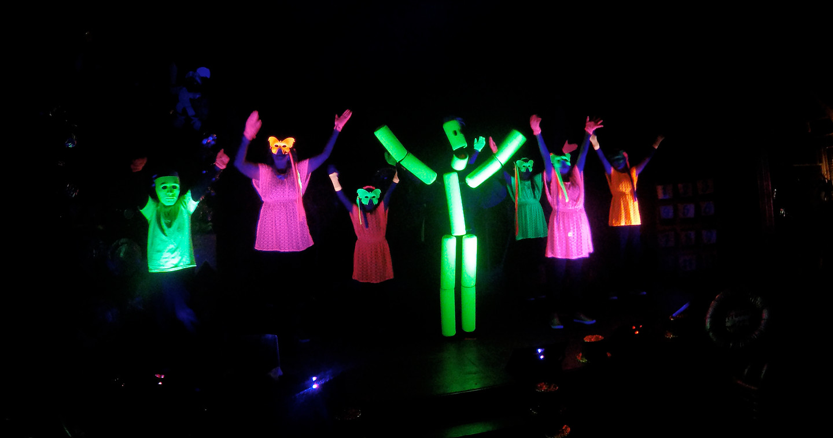
3:30 PM Grade 3-6 After School
Sports Program
Friday Gym Available for Rent
DCS Campus Safety
Your child’s safety is our top priority. In consultation with RCMP and the WRSD Health & Safety Officer we have decided to make some changes.

- Front doors will be unlocked at all times
- All other interior and exterior doors will be locked at all times.

We will be educating all students and staff. Thank you for your support in keeping our DCS students safe.

Report Cards and Parent Teacher Interviews
Report Cards will be coming home on November 18th
Parent Teacher Interviews will take place on November 22nd and November 24th. Please check your child’s report card for the date and time of your Interview. If you are unable to attend please call the office at (780) 542-7066.

