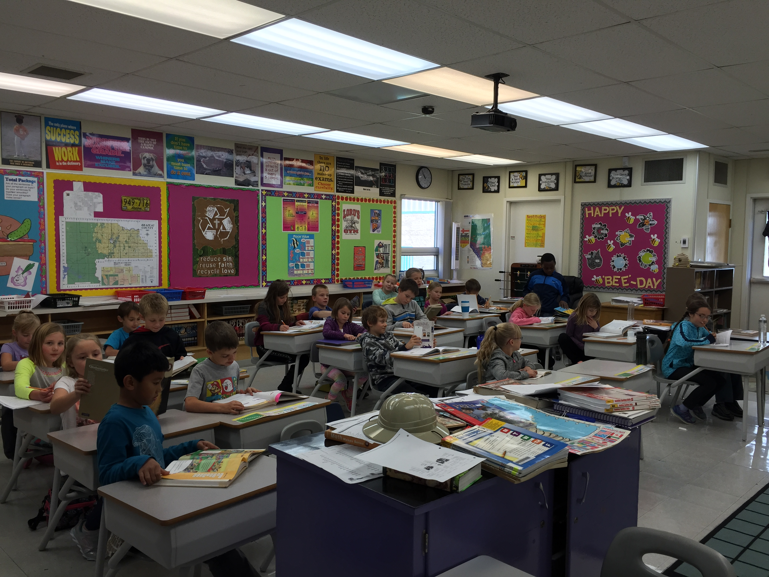

|  |  |  |  |  |
| --- | --- | --- | --- | --- |
|  |  | |  | | --- | | DCS News  “Be Excellent at What is Good” | | October | |
|  |  |  |
| Grade 3/4: learning lots! |  | 2016 |

**Dear DCS Family,**

**True Confessions: Fall is my favorite season. As an educator, I love embracing the newness of this time of year. In my mind, it is a time to start afresh. It has definitely been a new start for me in my new role at DCS, but I have felt that “fresh start enthusiasm” from many people in the DCS family.**

**During this time of year, we are also reminded to be thankful. I like how the translator of The Message puts it. “cultivate thankfulness.” God has been so very gracious to us and we have so very much to be thankful for.**

**I am thankful that we have 28 new students with us at DCS this year! I am thankful for the many dedicated certified and support staff that go above and beyond in their work with children and each other. I am thankful for a place where we can learn and teach about God and His world every single day.**

**I am thankful for the many volunteers who work faithfully to make Christian Education in Drayton Valley possible. I am thankful for each family that has entrusted their children’s education to us. I am thankful for each child and the honour of working with them. Most of all, I am thankful for Christ and that His peace keeps us walking His path together.**

**On behalf of everyone at DCS, I wish you a very happy Thanksgiving. I pray that you experience His peace throughout every step of your way.**

**In Christ,**

**Terri-Lynn Emms**

***Colossians 3: 15-17 The Message***

***“Let the peace of Christ keep you in tune with each other, in step with each other. None of this going off and doing your own thing. And cultivate thankfulness. Let the Word of Christ – the Message- have the run of the house. Give it plenty of room in your lives. Instruct and direct one another using good common sense. And sing, sing your hearts out to God. Let every detail in your lives – words, actions, whatever – be done in the name of the Master, Jesus, thanking God the Father every step of the way.”***

New Dismissal Time at DCS

Is 3:15 PM

A Huge Welcome to our New Staff!

Tracy Fortin

Educational Assistant

Janice Ueland

Educational Assistant

October 4th Lifetouch Picture Day

October 10th Happy Thanksgiving. No School for Students

October 11th-13th Dental Hygienist will be at DCS

October 20th-21st No School for DCS Students

November 9th Lifetouch Picture Retake Day

Weekly Events

Mondays Junior High Volleyball Practice 3:30-5:00

Wednesdays Worship Action Club (Last Recess)

Handball 3:30-5:00

Thursdays 8:35 Chapel (Everyone Welcome!)

Parents Who Pray (Meet after Chapel)

Grade 3-6 After School Sports Program 3:30-4:30 (Sign up forms available in the office)

Fridays Are you interested in booking a birthday party or special event? The gym is available to rent!

Upcoming Events at DCS

New Dismissal Time for DCS



Our School Day will end at 3:15 PM



Upcoming Drayton Valley Events













