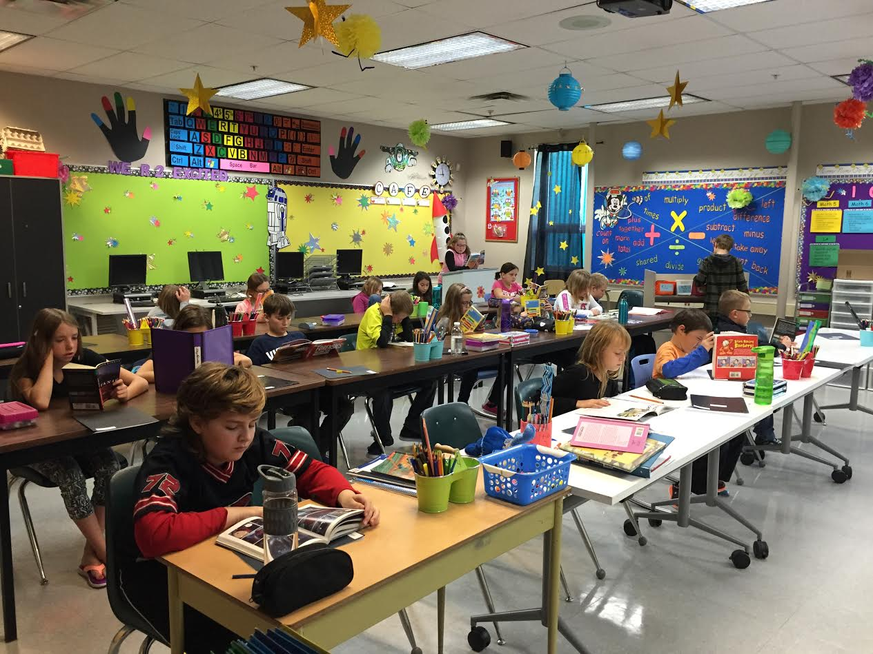

DCS News
  - “Be Excellent at What is Good”
  - September

Grade 5/6 Class |  | September 2016

“We are many parts of one body, and we all belong to each other.”
Romans 12:5b (NLT)

It has been such a pleasure working alongside all of you so far this year. Kudos to you parents for raising such amazing children. I have enjoyed meeting every one of them. Thank you for sharing them with us at DCS. We take the responsibility seriously. Kudos to the staff that work at the school. I appreciate their sincere dedication to doing what is best for the kids. Kudos to the Pastors and church members for supporting us, praying with us, and loving our families. Pastor Kenton prayed with us as a representative of the ministerial for our opening chapel. I hope that the pastors and church members join us often. Our program is designed for families, churches and the school to work together to grow each child into everything that God has called them to be. We are in this together. Think of it: God brought us together to help each other with this beautiful and challenging work of raising children. Each child belongs. Each staff member belongs. Each parent, grandparent, aunt, and uncle belongs. Each pastor and church member belongs. We are in this together and we all belong.
I am truly honoured to belong here with you at DCS. We are in this together.
You belong!
In Christ,
Terri-Lynn Emms

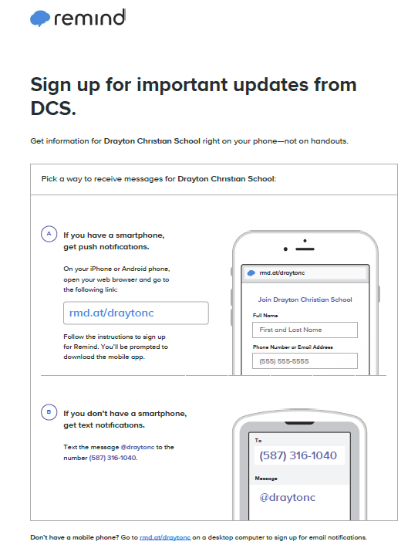

Worship Action Club
When: Wednesday
Time: Last Recess
Where: Miss Richert’s Classroom
Bell Schedule
8:30 AM Warning Bell
8:35 AM School Starts
10:35 AM Recess
12:20 PM Lunch
12:35 PM Lunch Recess
2:05 PM Recess
3:20 PM Dismissal
Phone Number (780) 542-7066
Website: http://draytoncs.wrsd.ca/
Find us on Facebook: https://www.facebook.com/draytonchristian
Remind 101
We want to stay connected!

Meet the Staff!

Mrs. Terri-Lynn Emms
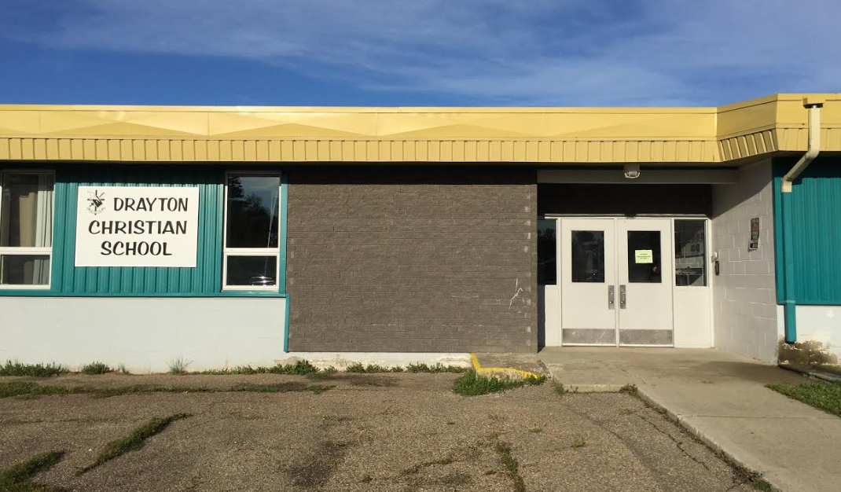
Principal/Kindergarten Teacher

Mr. Daniel Ceresa
Student Services Facilitator

Miss Tracy Schaible
Family Wellness Worker

Miss Kathy Haglund
Grade 1

Mrs. Leslie Janzen
Grade 2

A HUGE thank you to our custodial team for their hard work this summer to make our school ready for another year. The school looks great.


Mr. Daryn Breitkreuz Miss Karen Ellery
Grade 3/4 Librarian

Miss Trudy Richert Mrs. Barb Arychuk
Grade 5/6 Educational Assistant

Mr. Matt Nielsen Ms. Elisha Reid
Junior High Administrative Assistant

Mrs. Rhonda Mayer Mrs. Wiesia Demczuk
Educational Assistant Custodian

Mrs. Gina Gilbertson
Custodian

Toonies for Terry Fox
Please bring coins by September 30th
OFFICE HOURS: Our office is open from 8:15 am to 3:30 pm. If you are wanting to report your child’s absence, please call the office at (780) 542-7066. The office will be closed daily from 1:00 PM to 2:00PM

Parents Who Pray
We are a group of parents who pray for the students, staff, and all other requests
Where: DCS Room
When: Every Thursday
Time: 9:15 AM after morning chapel
Who: Everyone!! Please feel free to bring your infants and pre-school children with you as well.

Please join DCS Students and Staff for a time of Praise and Worship in the DCS music room every Thursday at 8:35 AM.
Thursday Morning Chapels
Upcoming Events
September 12th-16th Book Fair
September 19th No School for Students
7:00 PM Drayton Christian School Society Meeting
September 22nd Free Crash Course on Parental Controls in the Digital Age (see information below)
October 4th Lifetouch Picture Day

Drayton Christian School Breakfast Program
We want to make sure all of our students are fully prepared for academic success. The first step is ensuring that all students begin the school day with a nutritious breakfast at home or at school.
The School Breakfast Program is available every weekday for students and food is available in the DCS Office throughout the day. Please call the office if you have any questions or would like to volunteer for this program!
A HUGE thank you goes out to all the businesses for their financial donations and to the volunteers that have made this program a great success!

Grade 3-6 After School Sports Program
Attention Parents & Students
Starting Date: September 15th

The after-school sports program will be continuing this year at DCS! It runs every Thursday from 3:30 to 4:30. The program is free but only open to students that truly have a desire to learn the fundamental skills of each sport. We will start the year with volleyball and then move on to basketball. The goal is to allow students who are approaching junior high to learn and understand basic skills. These can then be further developed and refined in our school sports teams later on. There is no travel required in being a part of this as all sessions will be held at the gym.

2016-2017 Student Verification Forms
Each school year we are required by Alberta Education to collect information regarding enrolled students. We have sent a Registration Confirmation form home for each child. Your careful attention and immediate response is greatly appreciated! Please be advised that a copy of your child’s birth certificate MUST be made available to us. This requirement is mandated by Alberta Education

Junior High Volleyball
Practices: Mondays from 3:30 PM to 5:00 PM starting Monday, September 12th.

Drayton Christian School Discount Cards
$25.00 Each

Wild West Handball Club
All grade 4, 5, 6, or 7 students who would like to learn how to play team handball are invited to join the wild west handball club. Last year, students from all 5 elementary schools played. (Grade 3 will get a chance to join September 28th.)
Cost: It will cost nothing to try, but if you are invited to go to the tournament, fees are about $30.00 EACH.
dATES: eVERY wEDNESDAY FROM sEPTEMBER 7TH UNTIL nOVEMBER 9TH FROM 3:30 PM UNTIL 5:00 pm.
Where: Drayton Christian School Gym
Save $$$ at many of our local stores in Drayton Valley!
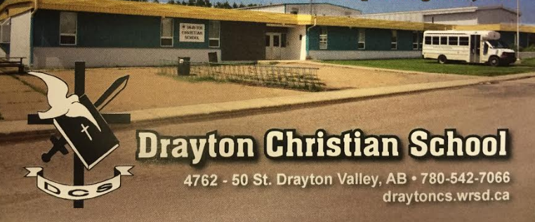
FREE CRASH COURSE ON PARENTAL CONTROLS IN THE DIGITAL AGE

Did you know that there is open internet access for anyone through our guest network at DCS (and all other WRSD Public Schools?). That’s right - anyone. That means that if your student has a personal device (smartphone, iPod, chromebook, etc.), it’s very likely that they can access the world wide web, unsupervised, during free time at school. This is not something that teachers can monitor during breaks and free time.

Want to know how to protect your child using parental controls on his or her device? Bring it, and join Mr. Nielsen for an evening of learning about how to guard your child’s integrity on the internet. YOU WILL NEED YOUR CHILD’S PASSCODE if the device is passcode protected. We’ll walk through how to enable parental controls on Android and Apple devices, and will also talk briefly about the Google suite of products that are available free to all Gmail users (our school uses these regularly - great for online forms if they didn’t get home).

This will also be a time to have a roundtable discussion with parent input about guidelines regarding appropriate device use at school. Please prepare some thoughts or concerns to share about this relevant and sensitive issue.

Join us on THURSDAY, SEPTEMBER 22, at 7:00PM in Mr. Nielsen’s Room. Please RSVP to our office (elisha.reid@wrsd.ca) if you plan on attending.

Keep up to date on what’s happening in Junior High
Mr. Nielsen’s Website
https://sites.google.com/a/wrsd.ca/dcs-jr-high/
Miss Richert’s Website
https://sites.google.com/a/wrsd.ca/missrichert/
Please be advised that DCS has an open campus policy during lunch breaks. This means that junior high students may leave the school premises during lunch break.
In the event that your child goes off-site, please share with your child(ren), your expectations as there will be no supervision available to those students who choose to leave campus.
If you do not want your child(ren) leaving the premises during the lunch breaks, please send a signed, dated letter indicating this to your child(ren)’s homeroom teacher.

Junior High News

