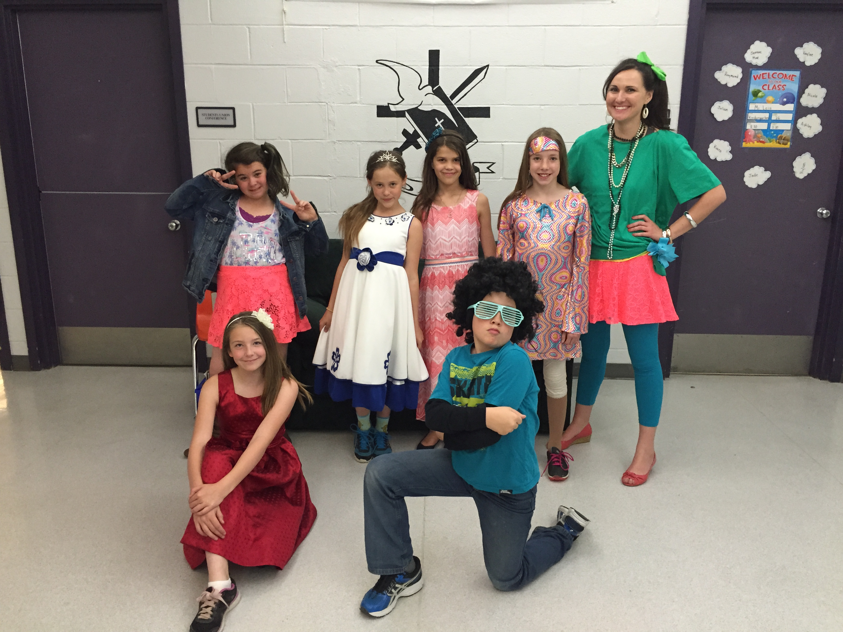

DCS News
  - “Be Excellent at What is Good”
  - June

Decade Day! |  | June 2016
As my time at DCS comes to a close I would like to say thank you to all the staff, students and parents for making my time here at DCS a wonderful experience filled with many memories. I came here in 2007 as the vice principal and have seen this school impact students lives. It has been a blessing to work with the DCS family during this time. Thank you for your support. DCS will always hold a special place in my heart and my prayers.

I am excited to announce that Mrs. Terri-Lynn Emms will be the new Principal of DCS. Mrs. Emms is an amazing lady with a deep passion for Christian Education. Please read a message from Mrs. Emms introducing herself following in this newsletter.

The close of this school year also sees DCS saying goodbye to Mrs. Pischke. After 20 years of working at DCS as an Educational Assistant Mrs. Pischke will be retiring at the end of this month. Over the 20 years Mrs. Pischke worked in every grade with a majority of her time being spent supporting students at the junior high level. Mrs. Pischke plans to be around our community and be a substitute for our staff but also looks forward to spending time with her family and time to travel and do some work with missions.

Mrs. L’Henaff will also be leaving DCS at the end of the school year as she is transferring to Aurora Elementary School and will continue her work with Vision students throughout Central Alberta. Mrs. L’Henaff has been a great ambassador for our students and has assisted many families at DCS in receiving support to aid in student success. Mrs. L’Henaff has also done amazing work with our student leadership team planning many community events.

God Bless,
Miss Golding

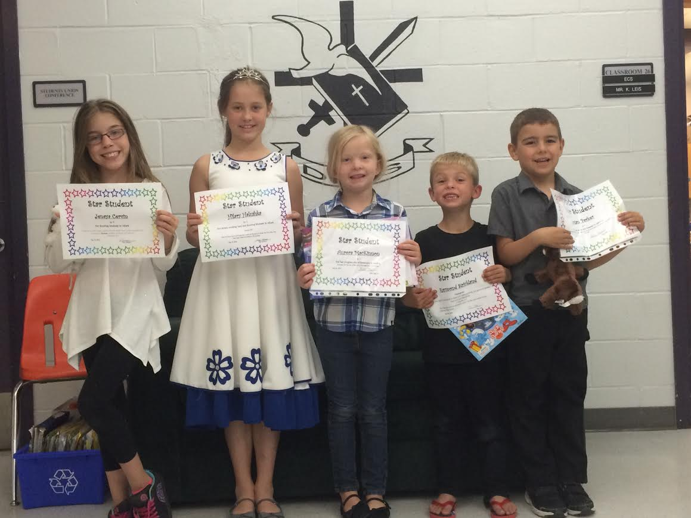

May Star Students!
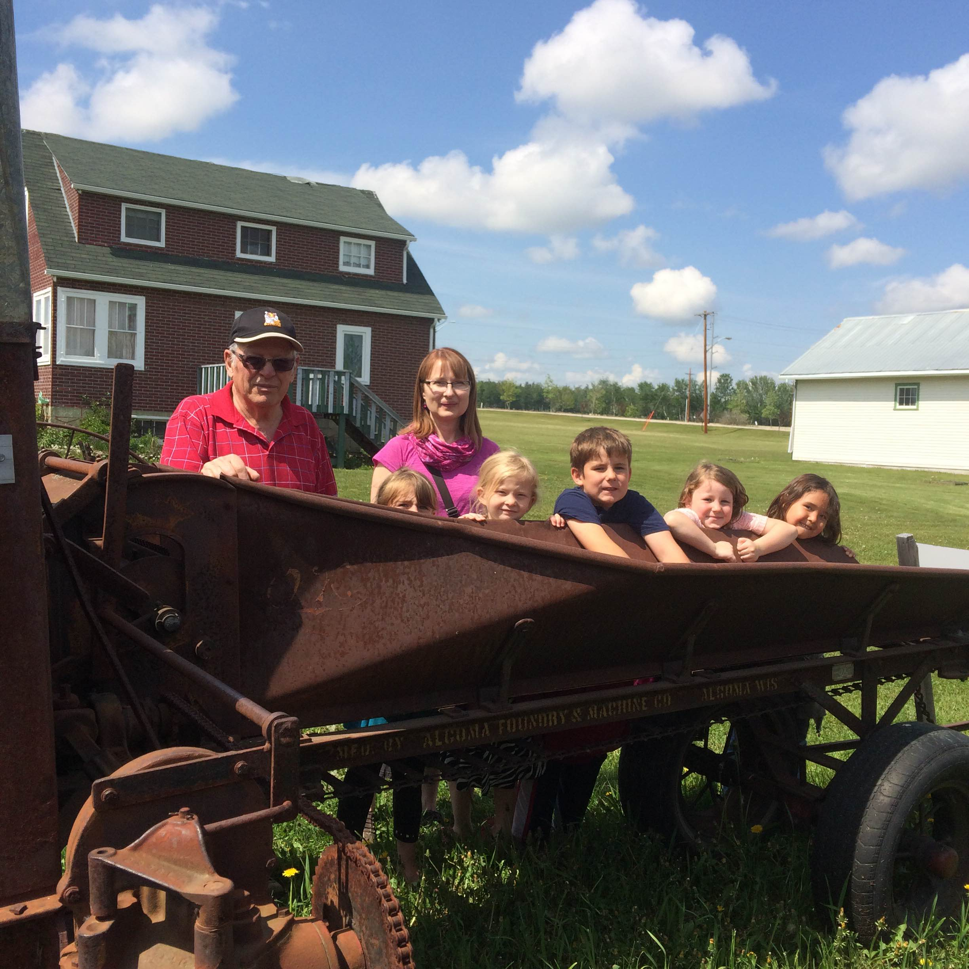

Grade 1 Museum Trip
IMPORTANT!!
Drayton Christian School provides your child with a faith-based education. In order to do this, we rely on an organization for Christian material, resources, and support. Association of Christian Schools International (ACSI) is the name of this organization. Every year we pay a fee per student to be a part of ACSI. Beginning next year, the Drayton Christian School Society has decided to ask every student to pay an additional fee, on top of tuition, to help with this cost. The extra $25 fee will reduce the need to fundraise. ACSI is a vital part of creating our unique program at DCS. We thank you for your understanding and commitment to Christian education.

June 10th Tacky Tourist Day
Kindergarten field trip to the Fire Station
June 13th Drayton Christian School/Society Meeting 7:00PM
June 15th 9:00 AM Grade 6 English LA Part B PAT
June 16th 9:00 AM Grade 6 Math PAT
June 17th 9:00 AM Grade 6 Science PAT
June 20th 9:00 AM Grade 9 Science PAT
9:00 AM Grade 6 Social Studies PAT
June 22nd 9:00 AM Grade 9 Math PAT
June 23rd 9:00 AM Grade 9 English LA Part B PAT
Kindergarten to Grade 4 Field Trip to Devon
June 24th 9:00 AM Grade 9 Social Studies PAT
9:30 AM – 3:00 PM Grade 2/3 and Grade 3/4 Field trip to the Museum
June 27th K-9 Free Swim
June 28th Awards Ceremony
Last Day of School

Exciting June School Events
EDUCATION WEEK
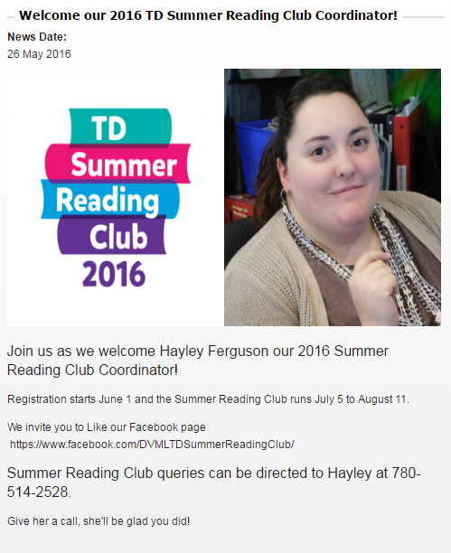
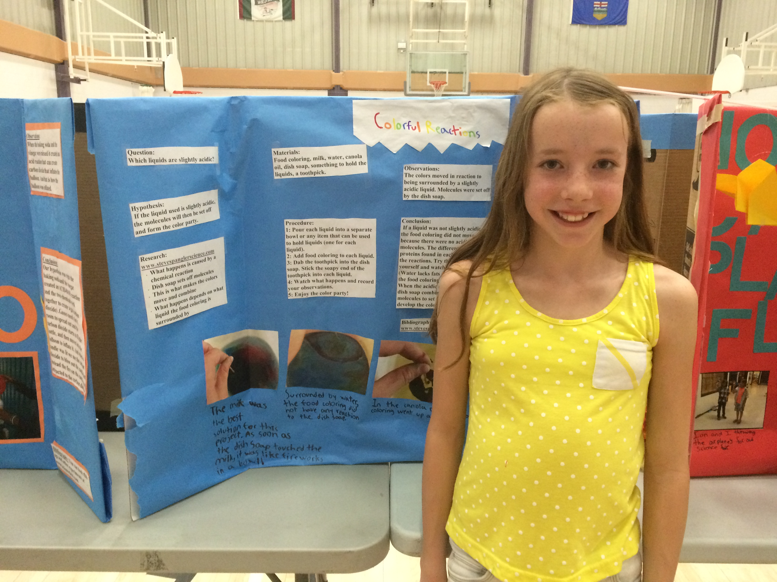

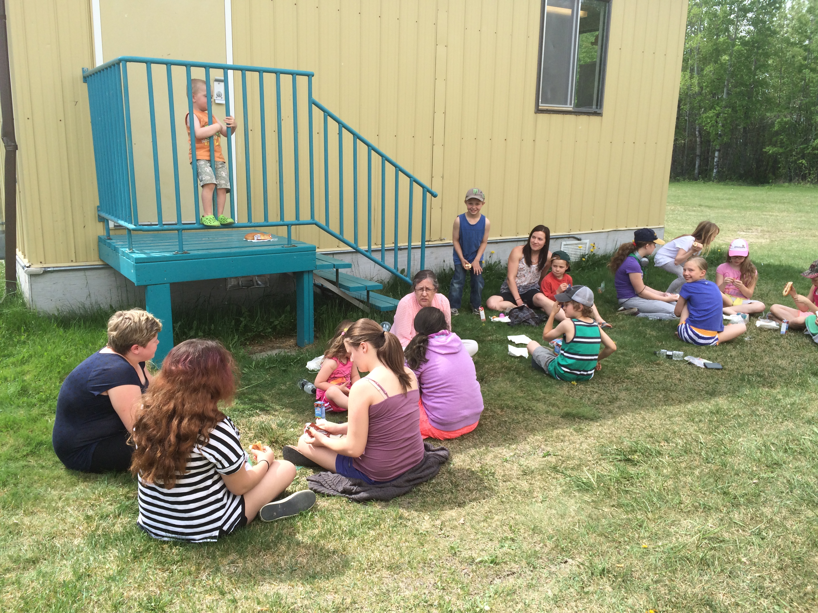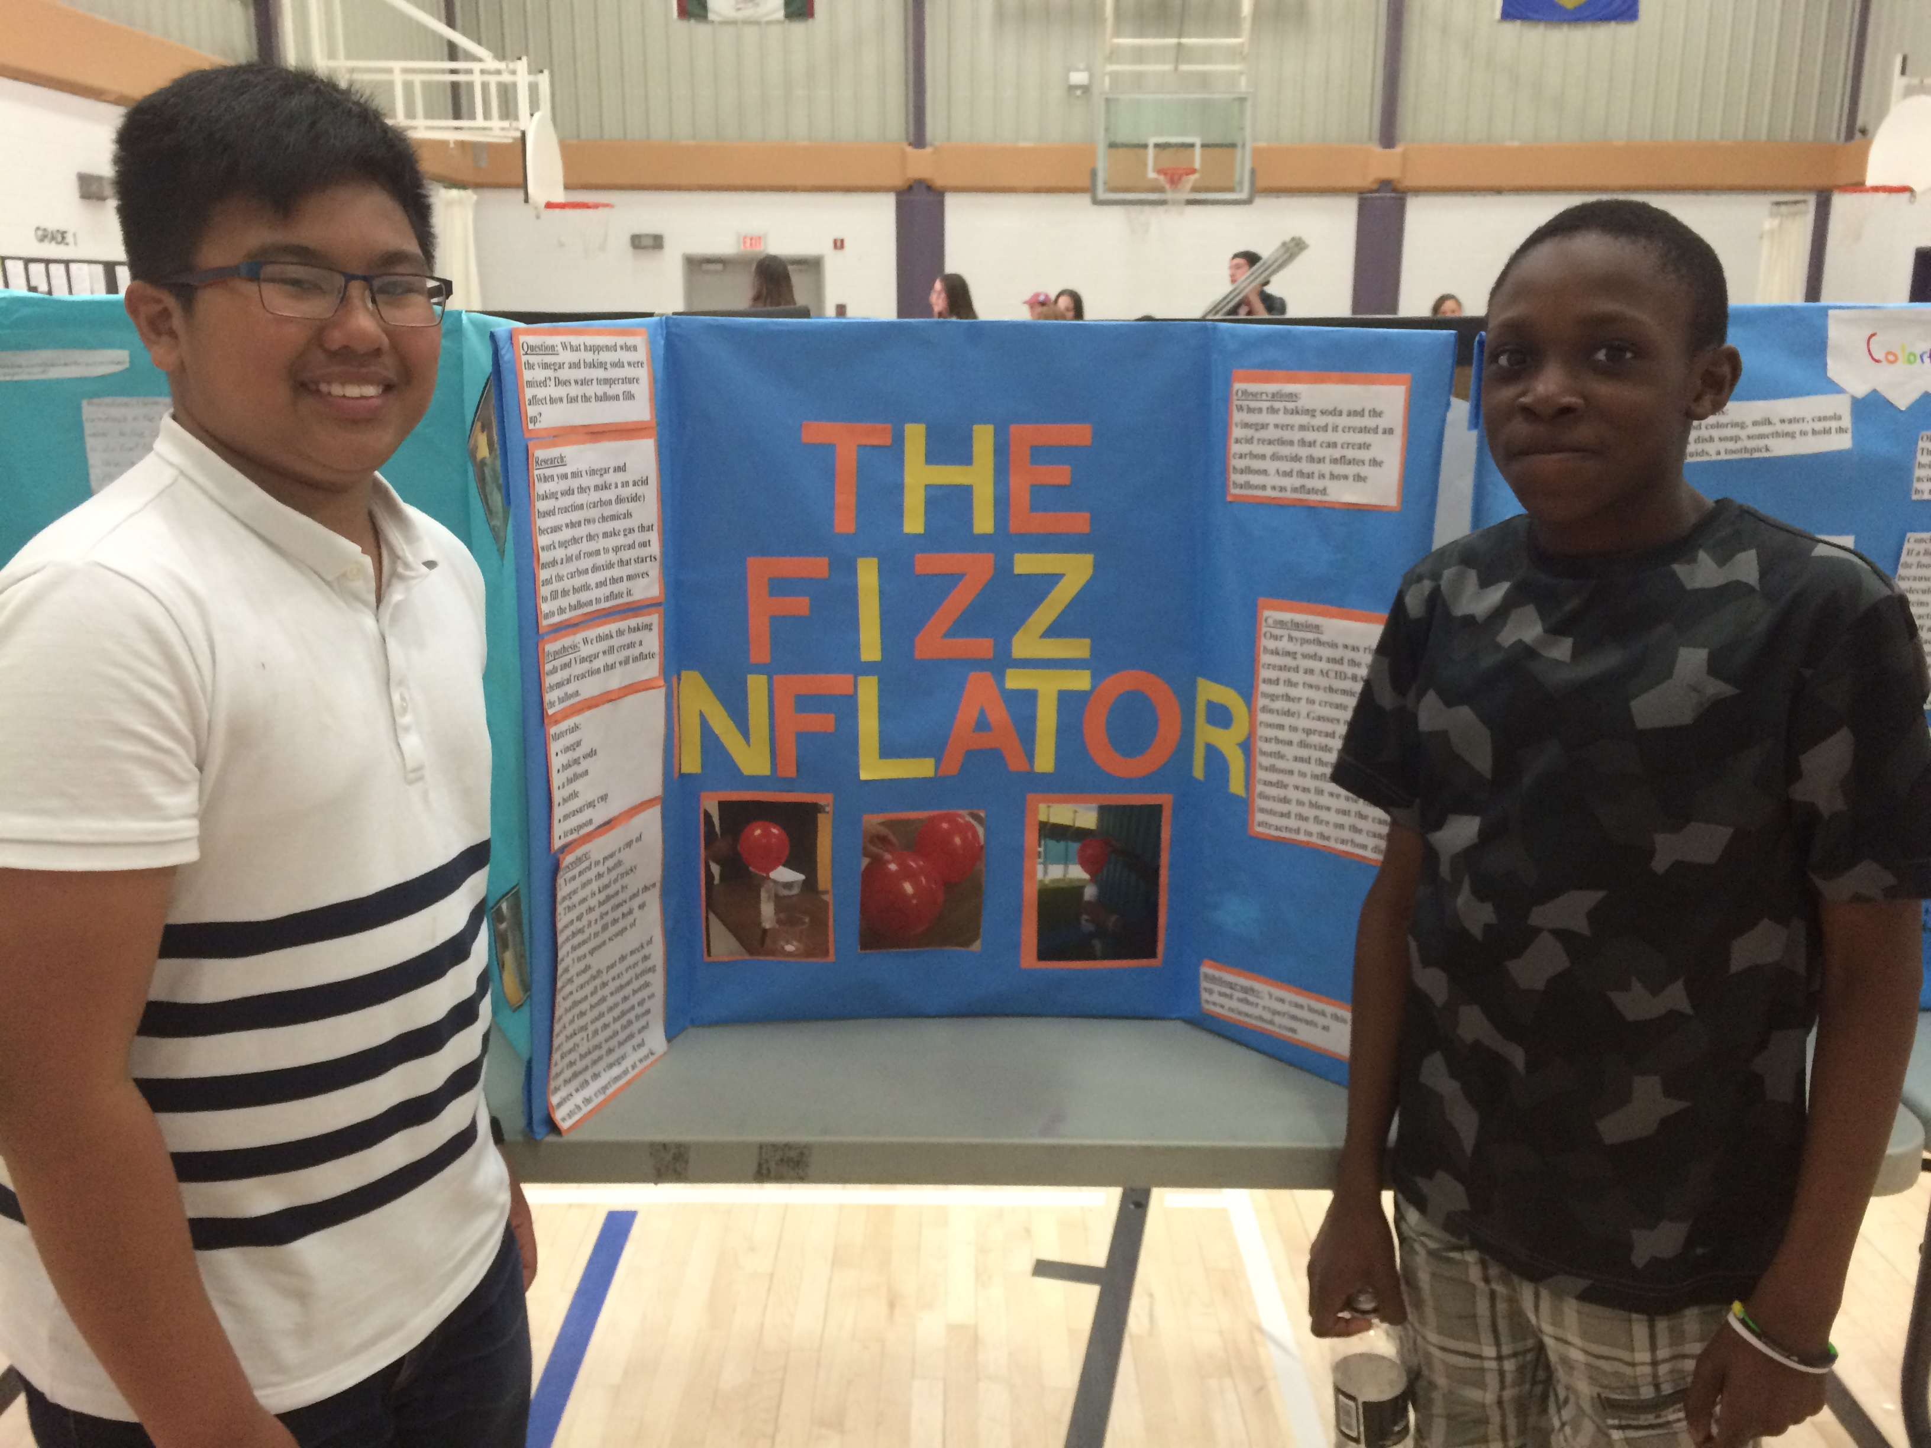

2016-2017 Bell Times

8:35 Classes Start
10:35-10:50 Recess
12:20-12:35 Lunch
12:35-1:05 Lunch Recess
2:05-2:20 Recess
3:20 Dismissal

Library Books
Please have all library books returned by June 15th, 2016
DCS Summer Office Hours
The DCS office will be closed from July 1st to August 24th and will re-open on August 25th.

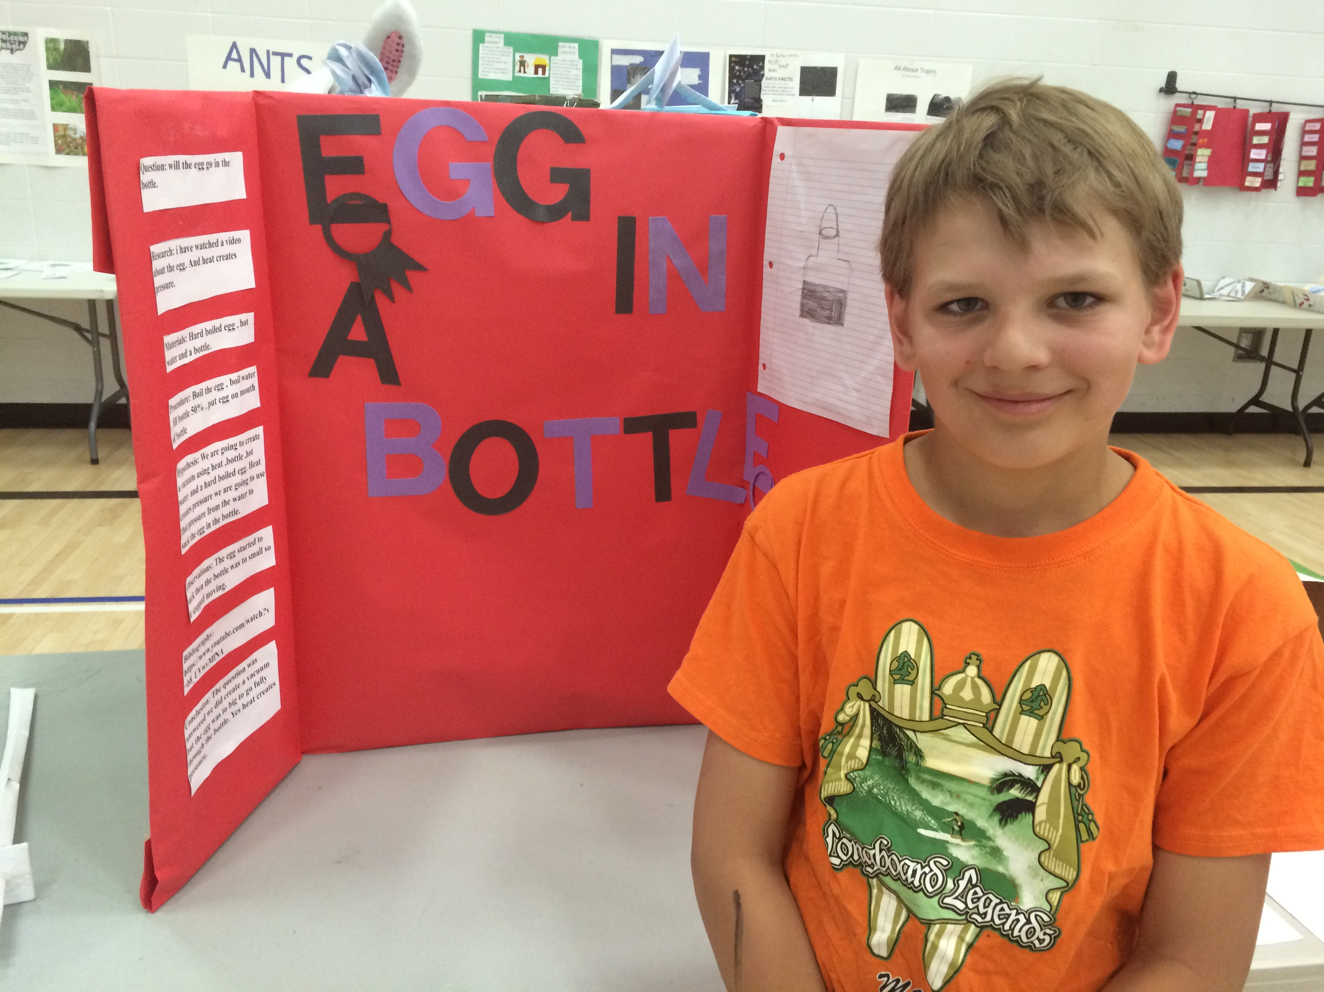
Housekeeping
Please be sure to check or have your child check the lost and found. Anything left after June 28th will be taken to the thrift store.
Terri-Lynn Emms

I am so excited to be joining the DCS school family. I have been praying for your school community for a number of years but especially during the recent transition period. I am thrilled and honoured to be able to serve you in the role of principal.

I have been teaching for more than 14 years. During those years I have had experience teaching in all the grades from Kindergarten through Grade 9. I have completed a Bachelor of Arts, Bachelor of Education, and a Master of Education Degree. My focus during my recent Master’s Degree was School Improvement and Leadership. I have always felt God’s calling to Christian Education and leadership and I have worked diligently to increase my knowledge and skills in order to serve His children with excellence.

My husband Kevin and I have been married for almost 16 years. We have 4 children. Jed is 14 and is excited to be a new driver. Luke is almost 13 and is a gearhead. Iraya is almost 12 and is loving being a pre-teen. Keaira is 9 and loves to spend time with friends. We are all looking forward to meeting you soon.

I pray that your summer will be refreshing and I look forward to working alongside you at DCS.

In Christ,
Terri-Lynn Emms

