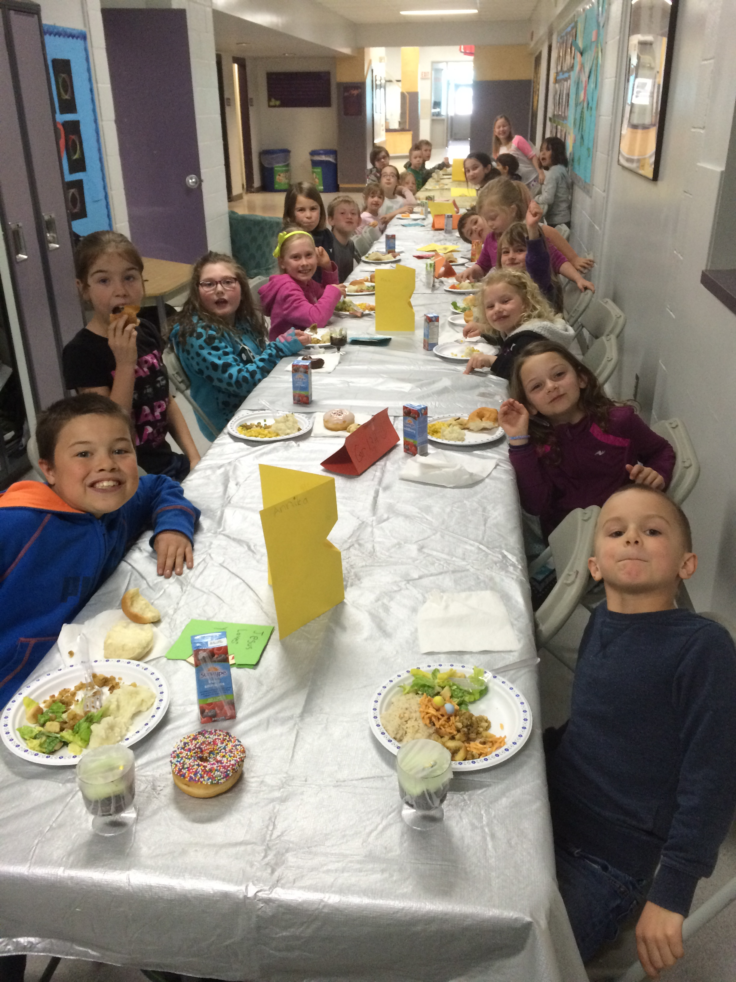

|  |  |  |  |  |  |  |
| --- | --- | --- | --- | --- | --- | --- |
|  |  | |  |  | | --- | --- | | DCS News  “Be Excellent at What is Good” |  | | May |  | |
|  |  |  |
| Easter lunch Celebration 2016 |  | May 2016 |

**Congratulations to all elementary classes on their excellent performances at the Drayton Valley Kin Club Performing Arts Festival.**

**It is with excitement that we share that the grade 2/3 students received a medallion and a provincial nomination for their performance! The 2/3 class will be heading to provincials on May 27th.**

**Principal’s Message**

**Spring is a time of new life and change, the grass is turning green and the glimpse of summer is within view. As we prepare for the summer, we also are preparing for the new school year ahead. It is with sadness, as well as excitement for what the future will bring, that I announce that I will be transferring out of Drayton Christian School to a new endeavour for the 2016-2017 school year. I have truly enjoyed everyone that has passed through these doors, and they all hold special memories I will cherish.**

**With the retirement of Grace Redford at Eldorado, my transfer, the economic uncertainties within the province, as well as with the communication with the Drayton Christian School Society, the division has decided to hire a single principal to oversee both schools as they are situated within the same building. There will also be a posting for a Vice-Principal for the Drayton Christian School.**

**I look forward to continuing to work with the DCS community over these next few months.**

**Warm regards,**

**Miss Lisa Golding**

**May Days Off**

May 6th No School for Students

May 19th & 20th No School for Students

May 23rd No School for Victoria Day



**Provincial Achievement Tests (PATs)**

Provincial Achievement Tests dates and times for the month of May are as follows:

Tuesday, May 10th 9:00 Gr. 9 LA (Part A)

Thursday, May 12th 9:00 Gr. 6 LA (Part A)

Some great ideas to get ready for testing:

* Get a good night’s sleep before the test
* Eat a good breakfast the morning before the test
* Ensure that your child has a proper pencil and eraser
* Be on time for school
* Wear comfortable clothes

Some great ideas for students to do well on their tests:

* Follow test directions carefully
* Read all answers before choosing one
* If you don’t know the answer, make the best guess
* Fill in the test bubbles completely
* Stay relaxed take deep breaths

Parents Who Pray

**We are a group of parents who pray for the students, staff and all other requests**

**Where: Boys & Girls Club Room**

**When: Every Thursday**

**Time: 9:00AM-9:30AM**

**Who: Everyone!! Please feel free to bring your infants and pre-school children with you as well.**





All fees are now past due. We are quickly approaching the end of the school year and need to close up outstanding fees.

Come in, or call the office if you need to make arrangements to pay fees in payments or to give a date of intended payment.

School Fees

**Education Week!**

Please join DCS for a Hot Dog Lunch on Wednesday, May 4th at 12:00 PM. After lunch there will be festival performances as well as a Museum of Learning with student art projects, writing samples, and other awesome pieces of learning! Please plan on joining us for this exciting afternoon!







Bouncy Castle Fun!

As promised, DCS will enjoy an afternoon of Bouncy Castle Fun on Thursday, May 5th! Great job winning the Disconnect to Connect Family Day Competition!



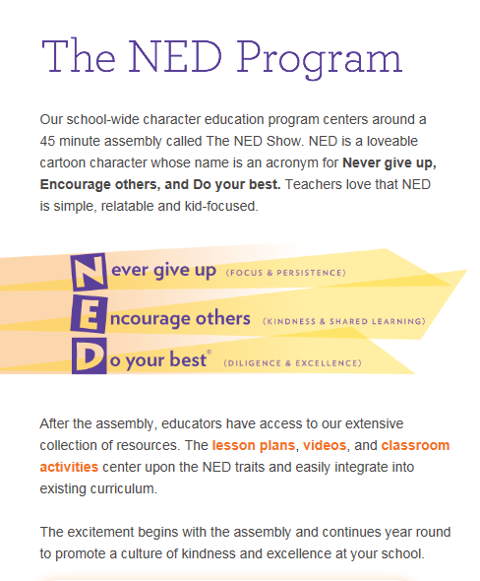

**Tuesday, May 10th at 9:00 AM**

Congratulations!!

**We hope to do this again next year! Thank you all for your support! Also, thanks to the Park Valley Pool for donating the swim passes and to the bowling alley for giving us discounted passes as well!**

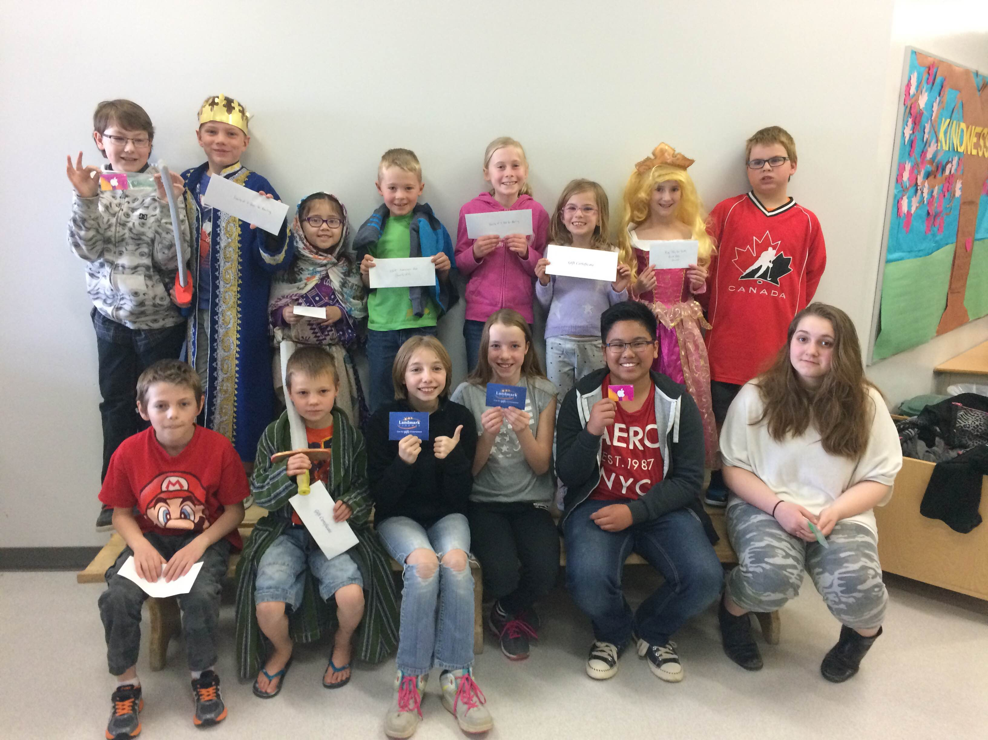

DCSS would like to congratulate the winners of the awards for the Spell-A-Thon Fundraiser!!

**Gift Certificate for the Park Valley Pool**

1. Astra Follett
2. Alandra Johnston
3. Jared Bent
4. Jade Dominguez
5. Ethan Brinks
6. Annika Penner
7. Cuyler MacIntyre

**Family Pass for the Bowling Alley**

1. Ellie Nielsen
2. Nolan Brinks

**Gift Card for Landmark Cinemas**

1. Zantelle Zelmer
2. Chris Trouton
3. Jody-Lynn Cornelson

**iTunes Gift Card**

1. Ethan Molinilla
2. Litasha McNeil
3. Ian Gray

**Grand Prize – West Edmonton Mall Attractions Pass for a family of 4**

Felix Nielsen

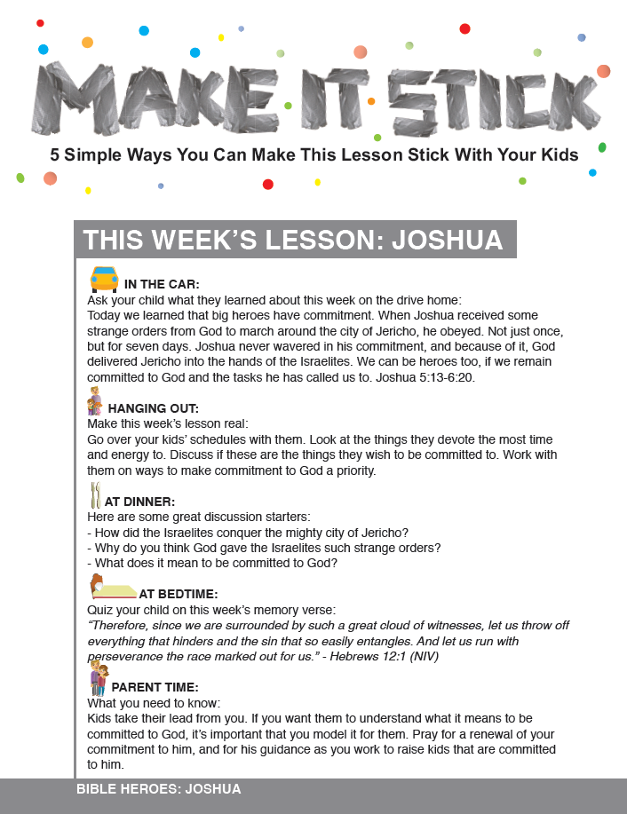

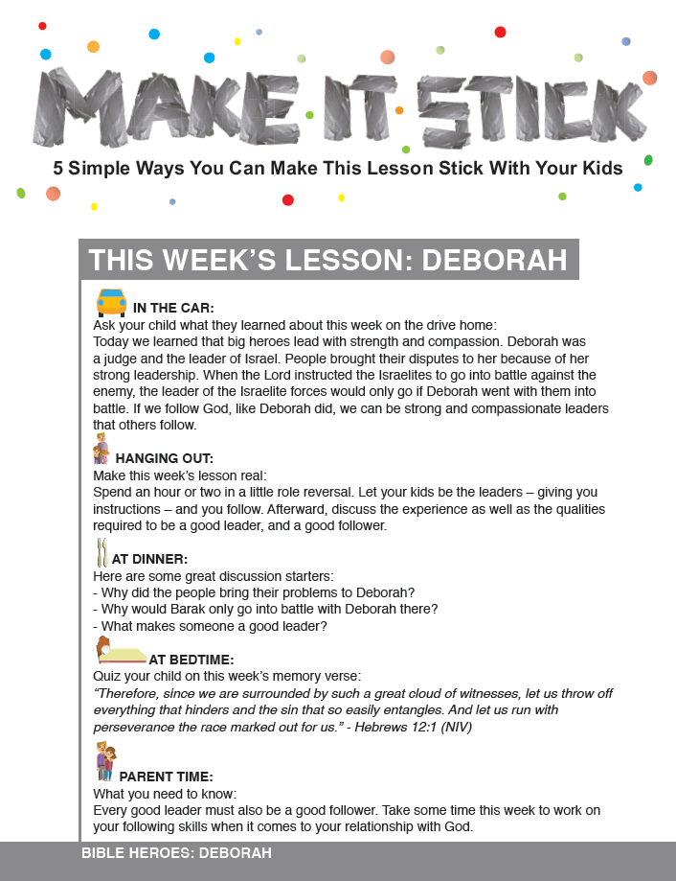

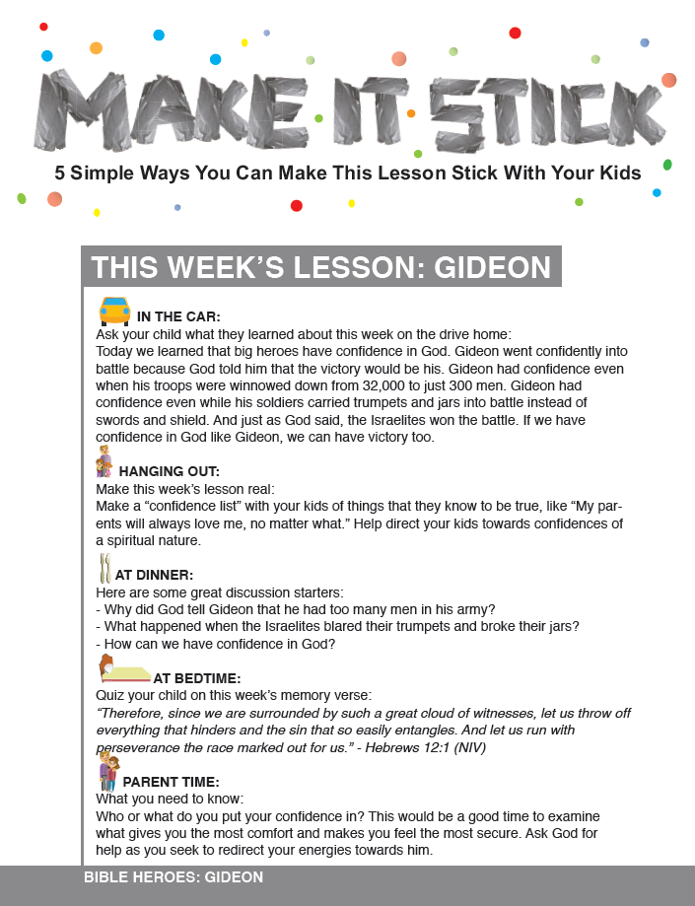

**Great Job at Festival DCS!**

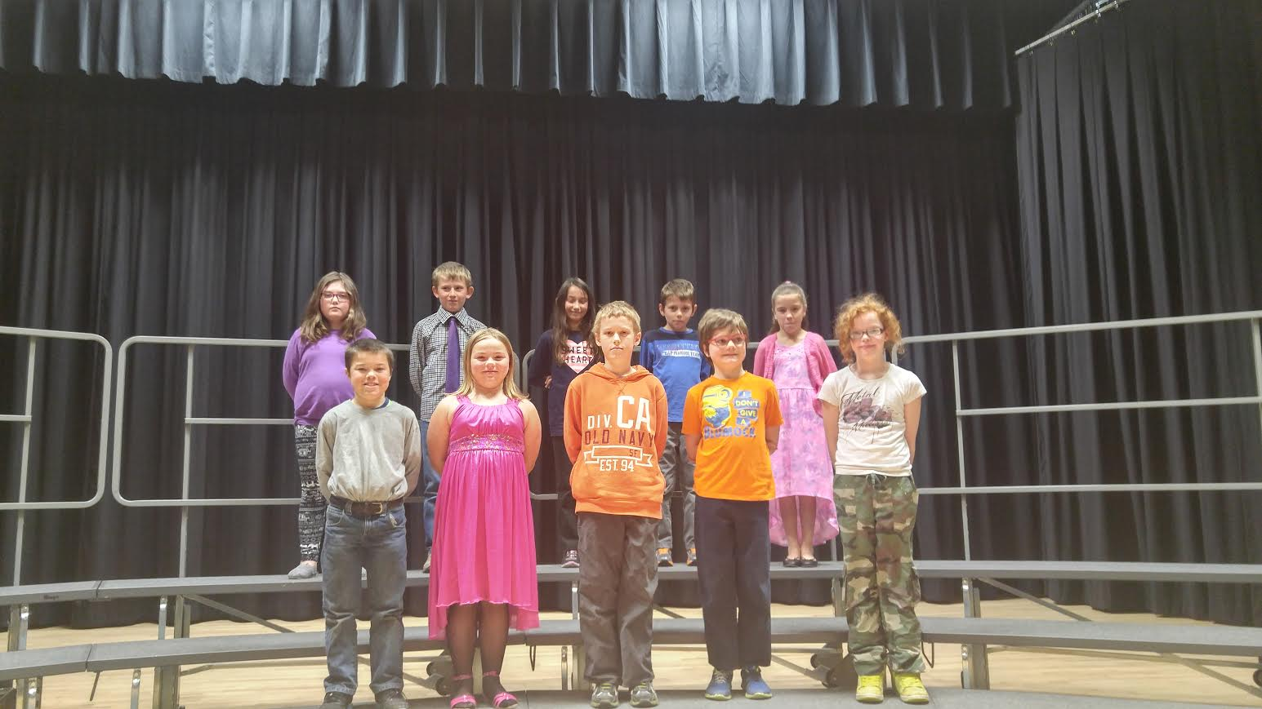

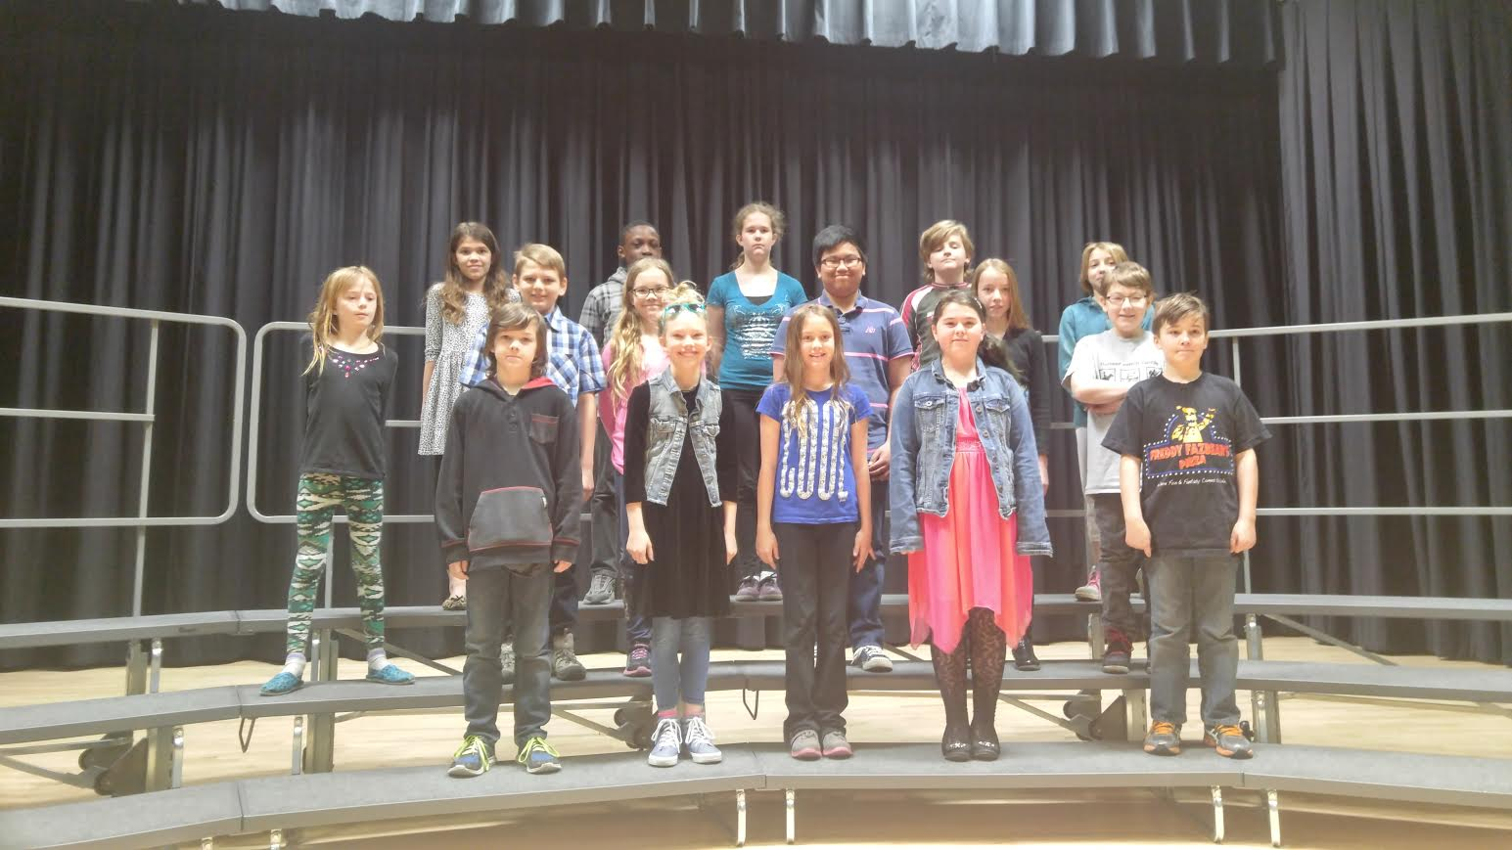

**Upcoming Events at DCS**

May 3rd Lifetouch Spring Pictures Day

Kindergarten & Grade ¾ Class Swimming

May 4th Hats on for Mental Health Day

DCS Education Week Hot Dog Lunch & Museum of Learning

May 5th Battle of the Books

Bouncy Castle Afternoon!

Kindergarten & Grade ¾ Class Swimming

May 10th 9:00 AM The NED Show (in the gym)

Kindergarten & Grade ¾ Class Swimming

May 12th Dental Hygienist at DCS for Kindergarten to Grade 2 Students

“The Great Canadian Shoreline Cleanup” Junior High

May 13th Fundscrip Order Forms Due back to School

Kindergarten to Grade 6 Comic character dress up day

May 27th Decade Day

8:45 AM Assembly

Grades 2/3 going to Provincial Music Festival



On May 12th, the Jr. High students will participate in “The Great Canadian Shoreline” cleanup, a Canada-wide initiative to get our waterways cleaned up. The Junior High students will be going to Eagle point Provincial Park for the cleanup. Any bottles or cans collected will go to the bottle depot, with proceeds going to our School Society. We would love to have any adult volunteers who would like to participate in any way such as cleaning up, supervising, or taking photos. Please email Mr. Nielsen if you are interested in attending or if you have any further questions at [matt.nielsen@wrsd.ca](mailto:matt.nielsen@wrsd.ca)

Junior High