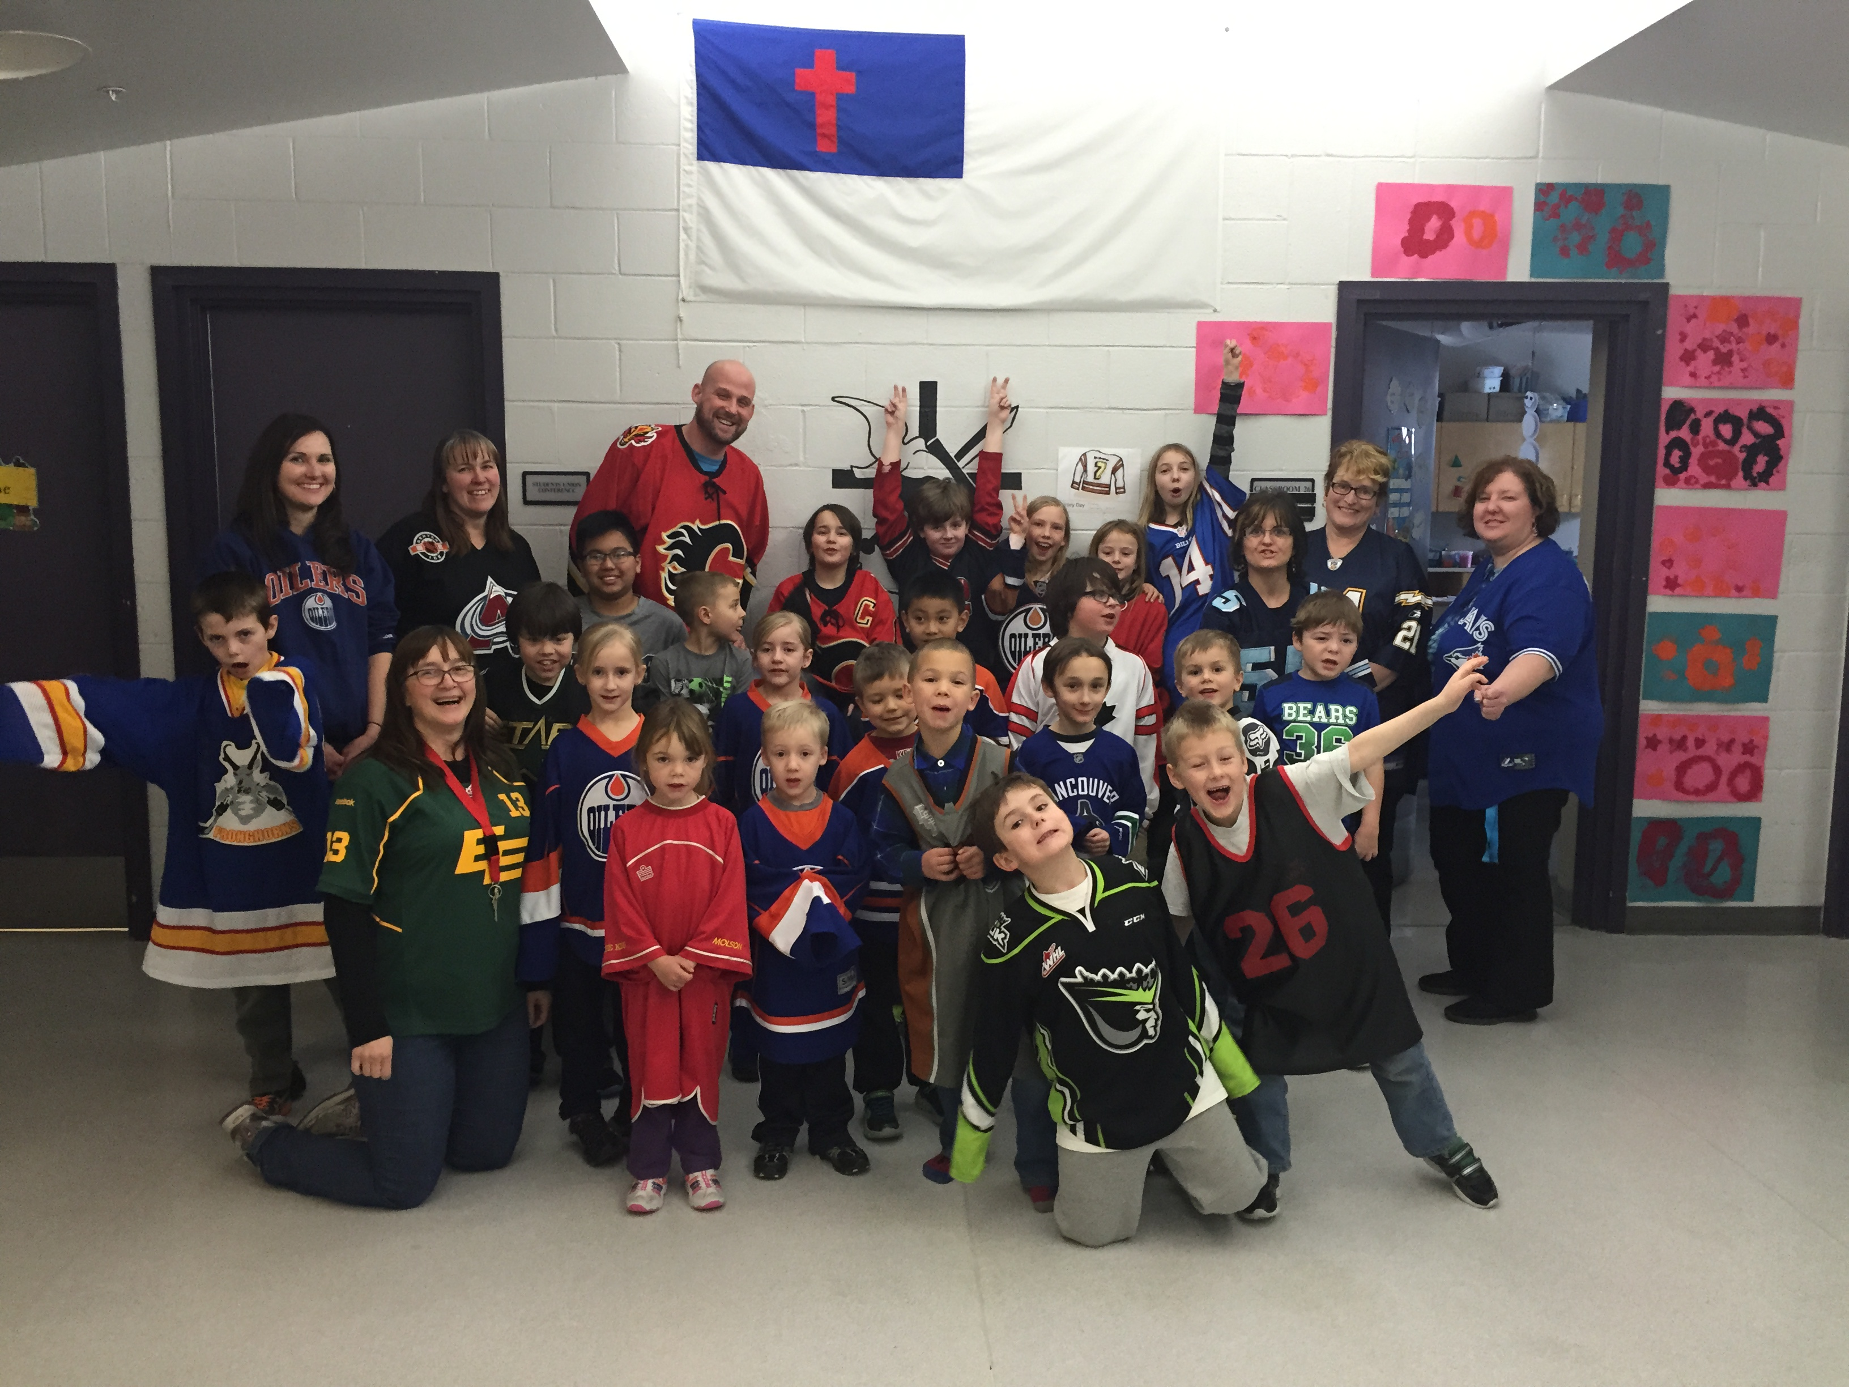

|  |  |  |  |  |
| --- | --- | --- | --- | --- |
|  |  | |  | | --- | | DCS News  “Be Excellent at What is Good” | | February | |
|  |  |  |
| Jersey Day 2016 |  | 2016 |

Dear DCS Community,

As we continue into February I feel, more than ever, that we as a Christian community need to come together and pray for our government leaders and our communities as a whole.  This month, in Alberta, we have seen suggested guidelines come down with the intention of creating welcoming, caring, and safe environments for our students.  Instead of unifying our efforts, these guidelines have caused division.  It is my prayer that, as a community, we will stand firm in our beliefs, and do so in love.   We do not know the journey those around us are on, or where in that journey they are.  Jesus calls us to be like him and show compassion and love while being firm in what we believe.

I invite you to join us on Feb. 3rd at 9:00 AM to pray for our government and our division leaders.

February 3rd 9:00 AM Pray for our leaders and Government

February 4th No School for students (Teachers Convention)

February 5th No School for students (Teachers Convention)

February 12th Wear Pink/Red for Valentine’s Day!

Winter Event Day!

February 15th No School (Family Day!)

February 22nd 7:00 PM DCS School Council/Society Meeting

February 24th Pink Shirt Day

February 26th Future Day

8:30 AM Assembly

**Bus Lane will be closed daily from**

**8:25 AM – 8:35 AM as well as after school from 3:10 PM – 3:25 PM**

February

**Bottle Drive**

The DCSS is having a bottle drive fundraiser! Bottles can be dropped off at the school on Friday, February 26th before 4:00 PM. On Saturday, February 27th the DCSS invites all families to participate in the bottle drive from 10:00 AM – 12:00 PM. Please contact the DCSS by email at [dcschoolsociety@gmail.com](mailto:dcschoolsociety@gmail.com)

Parents Who Pray

**We are a group of parents who pray for the students, staff and all other requests**

**Where: DCS Art Room**

**When: Every Thursday**

**Time: 9:00AM-9:30AM**

**Who: Everyone!! Please feel free to bring your infants and pre-school children with you as well.**



**FUNDSCRIP: Want to pay off your swimming lessons, option fees, or WRPS fees without spending money? Use Fundscrip! This system works by pre-buying gift cards for the things you already buy or for gifts. Cards can be purchased for groceries, fuel, and clothing, as well as many other options. Fundscrip then gives you the cards for the full amount and the school a percentage of each card (every card is different) which we hold in an account for you to use towards your child’s fees. We are now allowing you to pay your mandatory school fees but these fees must be paid by May 1st, 2016. You can also use them for all other fees such as swimming, skating, field trips, options etc. Some families have not paid a penny of their own money to pay for these things in the last couple of years.**



Kindergarten Registration

We are now accepting registration forms for the

2016-2017 Kindergarten year

Please call or stop by the office

(780) 542-7066

**





*The boys and girls club of drayton valley is currently assessing the need for before school care in the community for the 2016-2017 school year. if you would be interested in before school care for your child(ren) for the 2016/2017 school year, please contact sandie labrie, program director at (780) 514-3400 or* [*sandie@bgcdraytonvalley.ca*](mailto:sandie@bgcdraytonvalley.ca) *to express interest.*



Winter Event Day!

February 12th

Please send your child to school with warm clothes such as snowpants, winterboots, mitts etc.

**Future Day!**

**February 26th, 2016**

**February 24th, 2016**







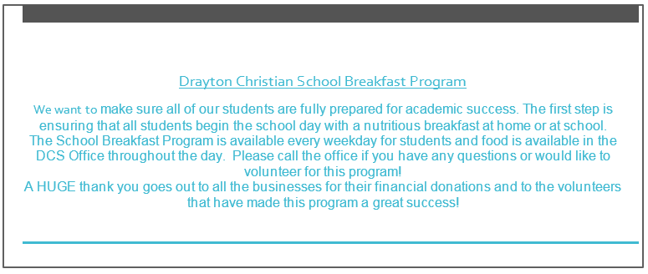



Pray for our Leaders and Government

Please Join Us

Join us on February 3rd, 2016 at 9:00 AM for a time of prayer for our Government and Division leaders. We will pray for wisdom and guidance. This is the day that our board will be writing their policy.



Medications

Just a reminder that all medications need to be brought to the DCS office. If your child requires medication please stop by the office to fill out a Medication/Personal Care Request Form. Absolutely no medication is to be kept in lunch boxes/lockers.

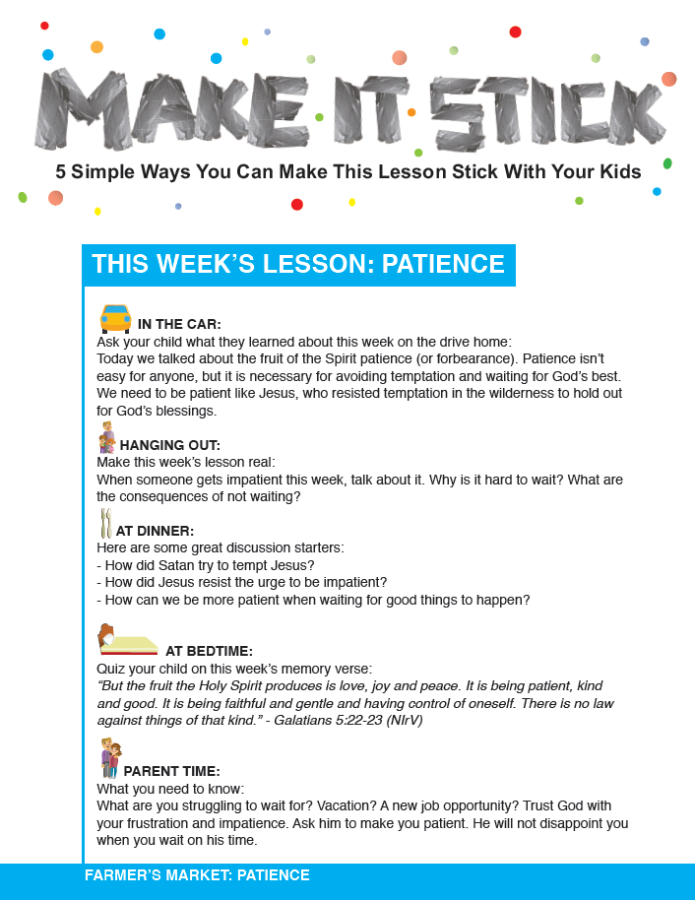

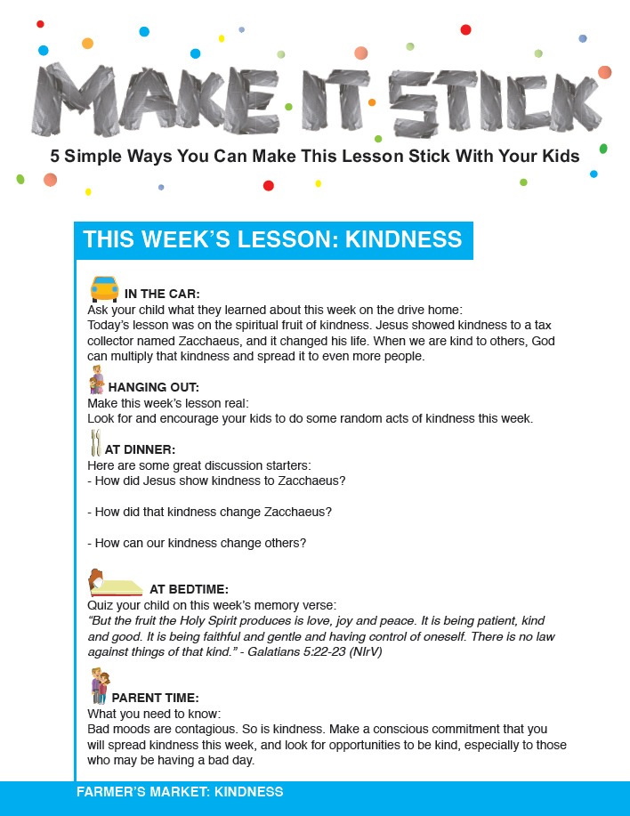

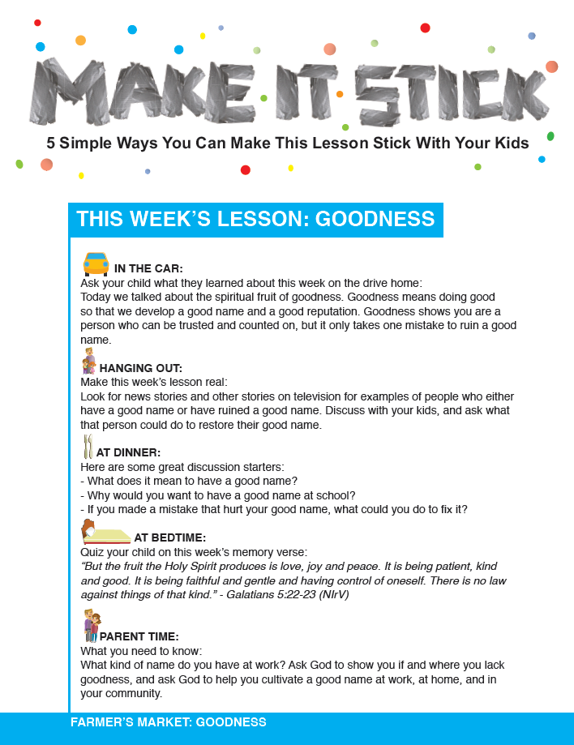

Parents, we need your help

School Accountability Survey

**As an annual check-up on the education system, the Accountability Pillar provides an opportunity for Alberta Education and school authorities to ensure that we are equipping students for success.**

**The Accountability Pillar uses a set of 16 indicators consisting of surveys of students, parents, and teachers on various aspects of quality.**

**All surveys are anonymous and ask questions about experiences with the school. Your participation in the survey helps to provide important information on the quality of education your child is receiving, so we encourage you to return your survey promptly.**

**Survey results will be available to school authorities in May 2015, and will be reported publicly as part of their 3-Year Education Plans and Annual Education Results Reports.**

**National Literacy Day!**

**Stories & Stuffies at DCS**

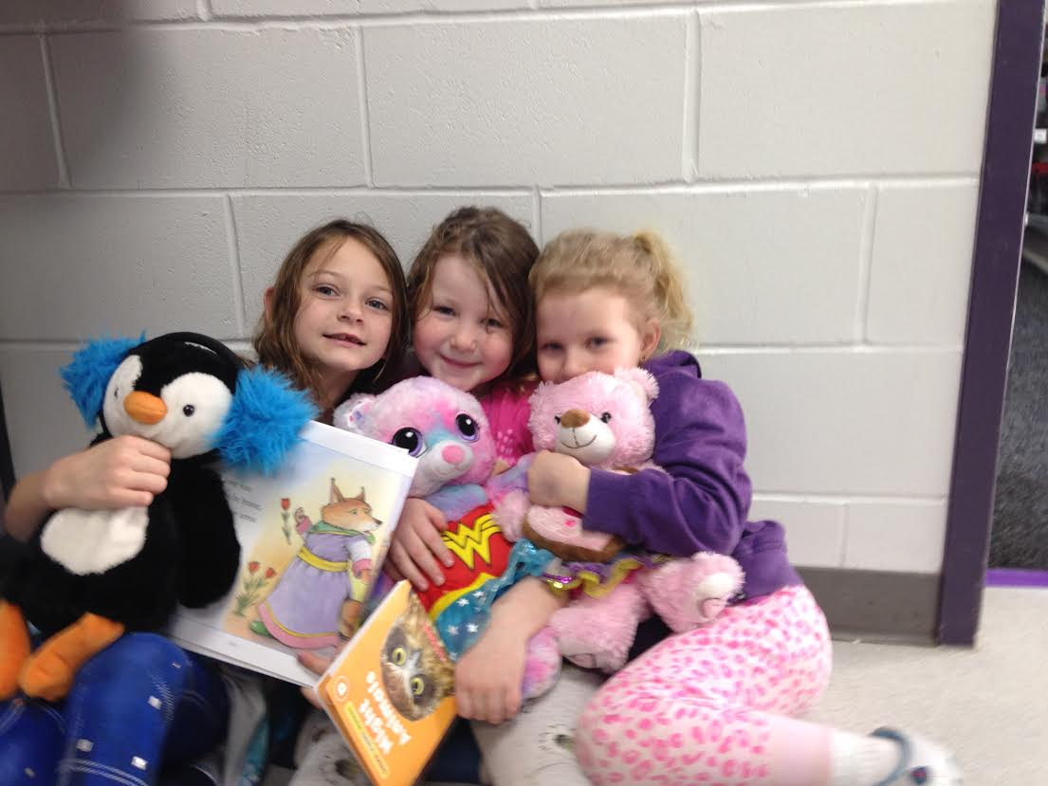

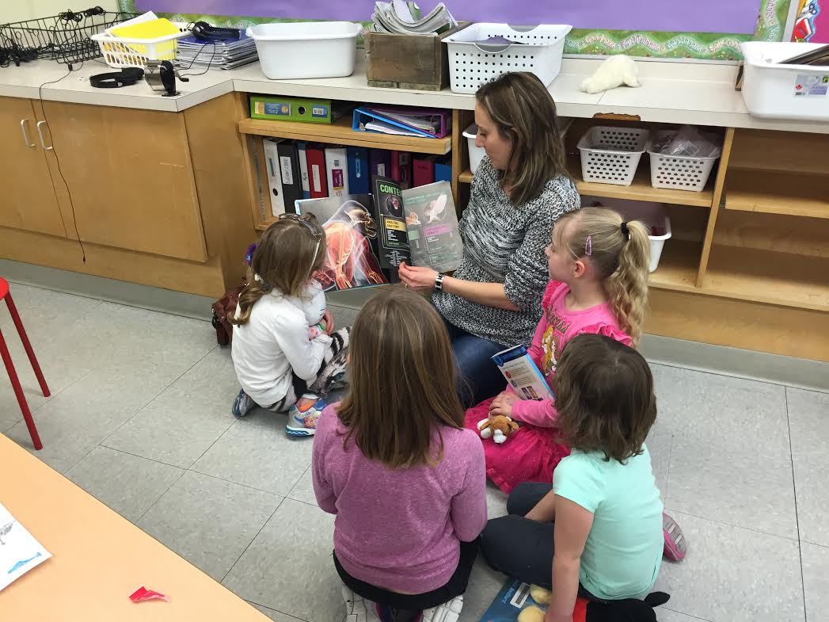

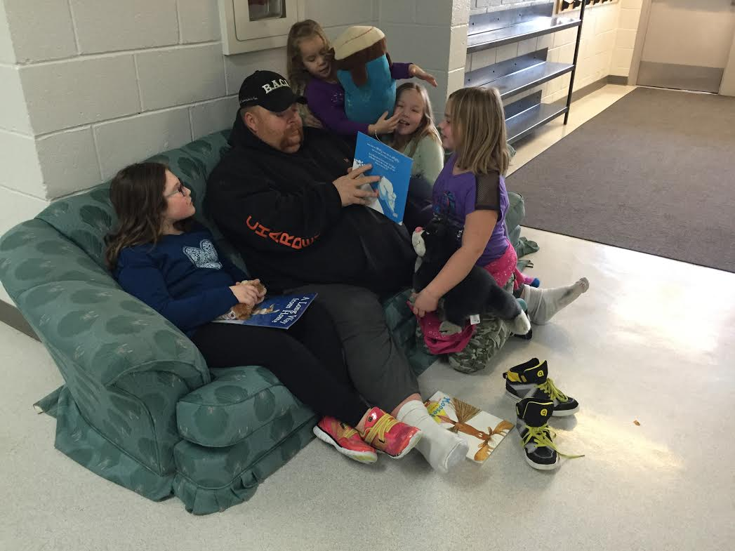

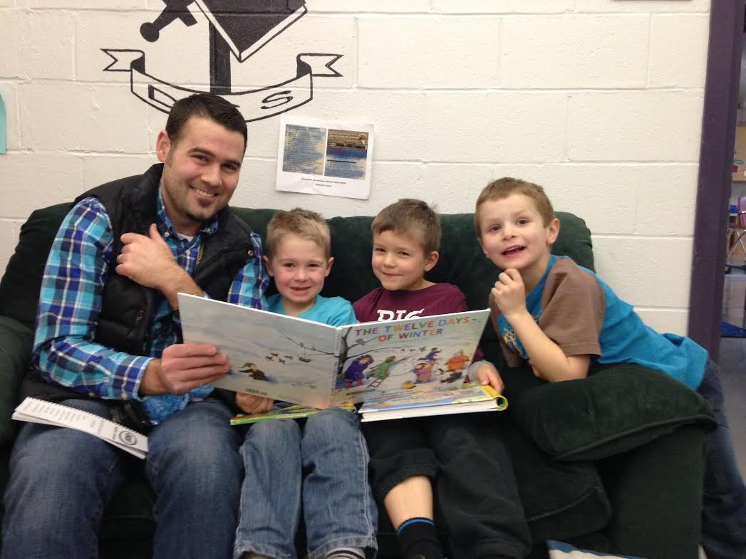



Check out these Stars!!

January Star Students and “Caught You Doing Good” awards!

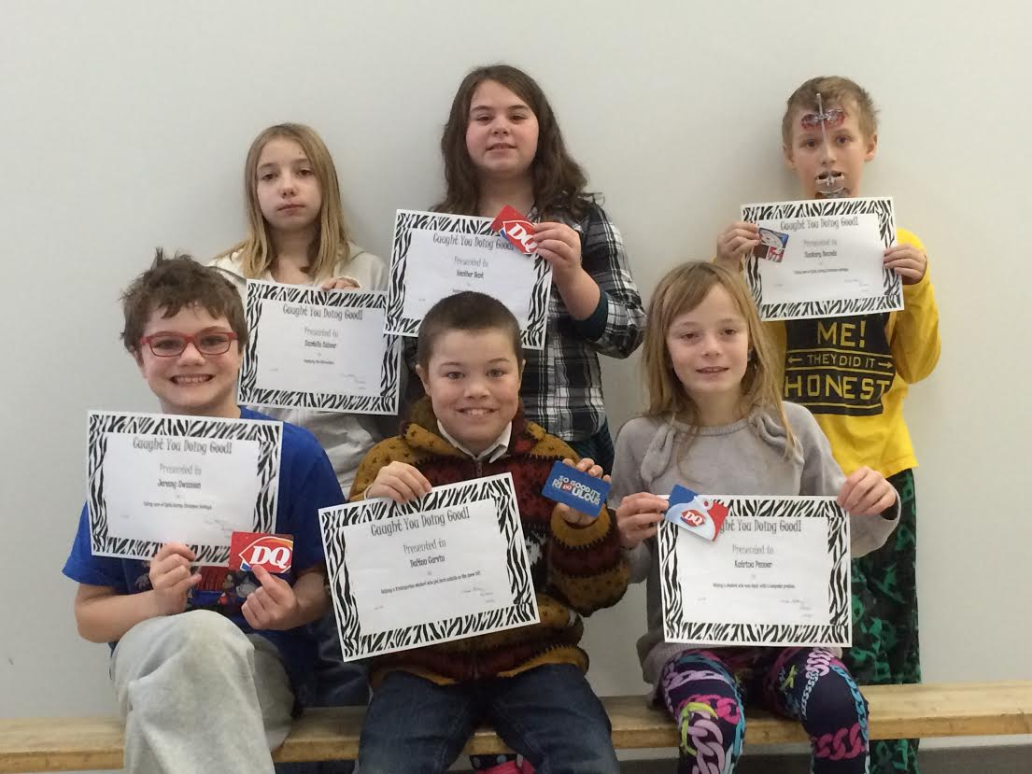

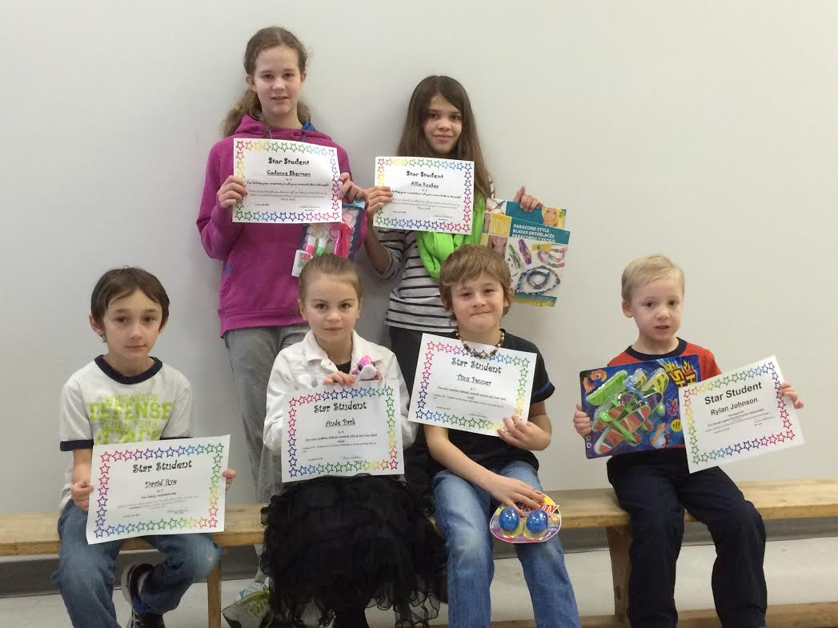



DCS Bus Lane

On January 4th we transitioned from being the Bus Hub to having a Bus Lane at our school.  We are still in the process of investigating to find the best practices for the safety of our students.  It has been made clear that no vehicles are to be travelling in the Bus lane while Buses are unloading and loading.  To accommodate this we are looking at having the Bus Lane closed from 8:25 AM-8:35 AM and 3:10 PM -3:25 PM.  If you are parked in the Bus Lane before these times please note that you will be asked to stay parked until the buses have left the lane.  I understand there is a concern with buses sitting in the lane longer than needed.  I have talked to Transportation about asking bus drivers to move down to the end of the lane once their initial checks for students have been done.

Please e-mail [elisha.reid@wrsd.ca](mailto:elisha.reid@wrsd.ca) to receive your newsletter by e-mail.