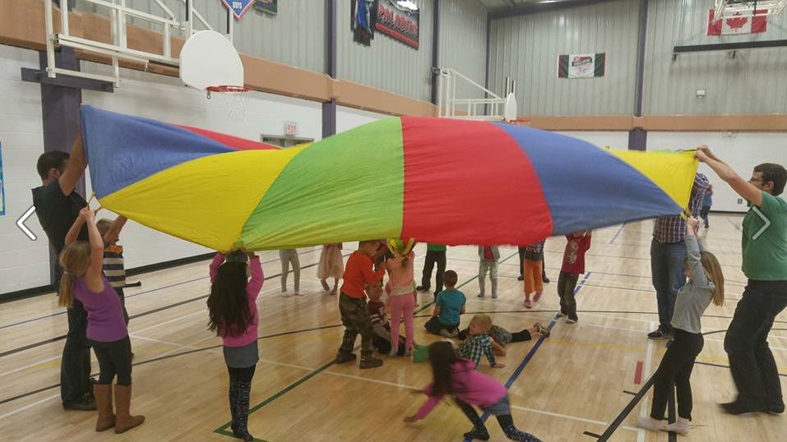

|  |  |  |  |  |
| --- | --- | --- | --- | --- |
|  |  | |  | | --- | | DCS News  “Be Excellent at What is Good” | | October | |
|  |  |  |
| Meet the Teacher BBQ |  | 2015 |

**"And whatever you do, whether in word or deed, do it all in the name of the Lord Jesus, giving thanks to God the Father through him."  Colossians 3:17**

As the Thanksgiving season is upon us, I would like to say that I am truly grateful to be a part of our DCS community.  As the principal, I am very thankful for the staff that God has brought to DCS to assist families in educating their children.  We have a great team of people who truly love God and love your children. Their dedication to God's calling on their lives is truly amazing.

I am also thankful for the students of DCS as they work hard to learn and willingly offer to help staff, other students and parents. They truly look to God in worship.  It has been a blessing to lead morning devotions and hear our students praising God through singing.

I am very grateful for our school community of parents, grandparents, and local pastors for their support, feedback, and encouragement as we continue to build DCS into a Christ-centered, caring, compassionate learning community.

I feel very blessed to be a part of this community.

Have a wonderful Thanksgiving!

Are you interested in helping out with the hot lunch program this year?

Please call Melanie Nielsen at (780) 234-9808 for more information

Hot Lunch



!

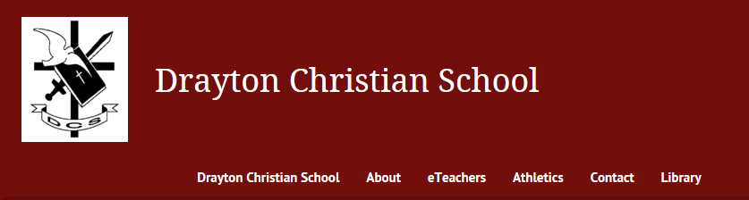

October 1st 3:45PM-4:45PM Grade 3-6 After School Sports Program

October 2nd Farm to school Fundraiser due by 10:00AM in the office

October 6th Lifetouch Picture Day!

October 8th 8:30AM All School Chapel

October 9th Fundscript Order Due

October 13th Crazy Hair Day

5:30PM-8:30PM Parent Teacher Interviews/Community Games Night

October 15th 3:45PM-4:45PM Grade 3-6 After School Sports Program

October 17th ECS Fundraiser

October 19th 7:00PM DCS School Council/Society Meeting

October 22nd No School for Students (Staff at ACSI)

October 23rd No School for Students (Staff at ACSI)

October 26th Fundscript Order Due

October 27th Duck Dynasty Day

8:30AM Assembly

October 29th 3:45PM-4:45PM Grade 3-6 After School Sports Program

Upcoming Events

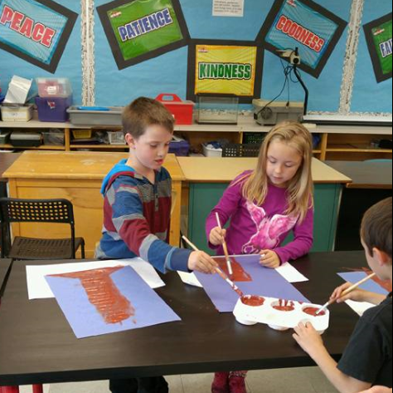

“Love the Lord your God with all your heart and with all your soul and with all your strength and with all your mind; and, love your neighbor as yourself.” Luke 10:27

**Our DCS Webpage**

**http://draytoncs.wrsd.ca/**

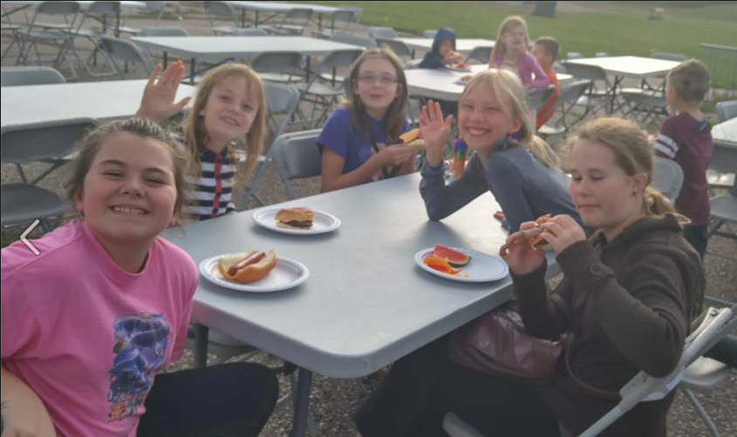



Grade 3-6 After School Sports Program

**ATTENTION PARENTS AND STUDENTS!!**

**A new, after-school sports program has started for students in Grade 3-6. It runs every Thursday from 3:45 to 4:45. The program is free but only open to students that truly have a desire to learn the fundamental skills of each sport. We will start the year with volleyball and then move on to basketball. The goal is to allow students who are approaching junior high to learn and understand basic skills. These can then be further developed and refined in our school sports teams later on. There is no travel required in being a part of this as all sessions will be held at the gym.**





Find us on Facebook!

https://www.facebook.com/draytonchristian



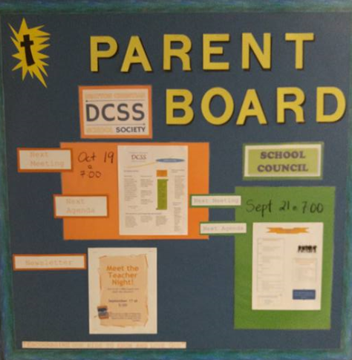



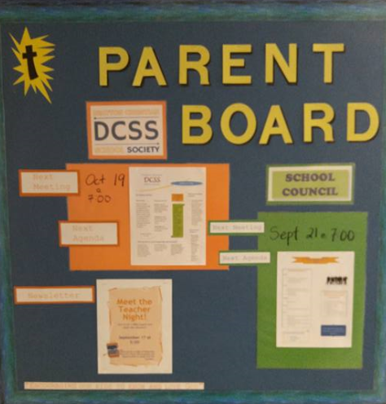

Check out our new

Parent

information board!

(Located at the DCS Front Door)

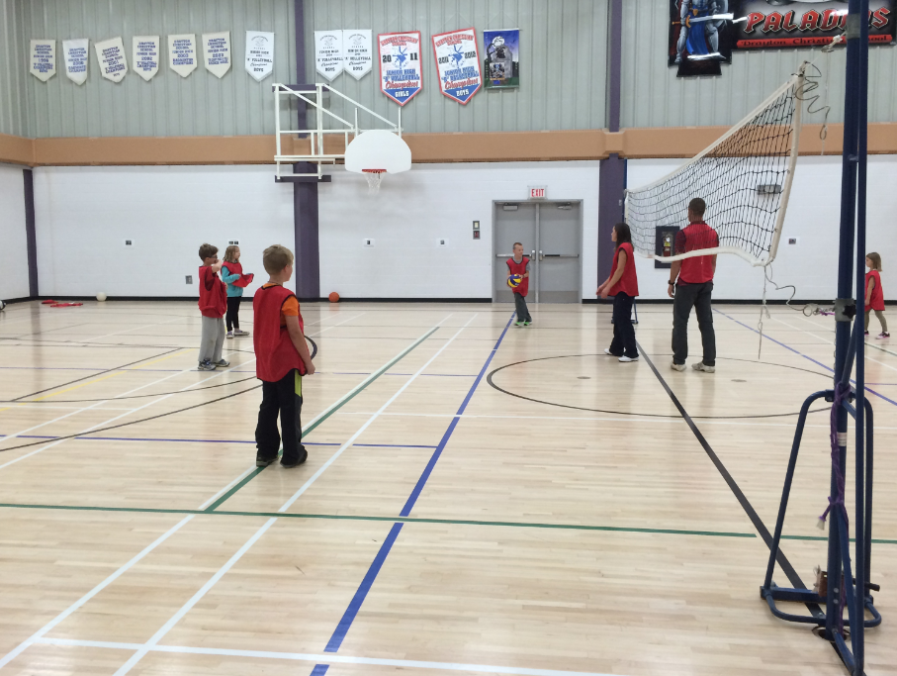





**You are Invited**

**Wild Rose School Division will be hosting an Umbrella School Council meeting at Buck Lake on November 26, 2015. We will begin with supper at 5:30pm followed by a meeting from 6:30 to 8:00pm. The meeting will follow a discussion format and topics for discussion will be generated by our School Councils. For example, possible topics could include practical tips like running effective meetings, attracting volunteers or fundraising. Or, topics could include issues like the use of technology in schools or the future direction of curriculum. Another important part of the meeting could include the sharing of ideas that are working well in each of your School Councils. Ultimately this meeting is for parents (not teachers or school administrators) and as such we want the topics to be generated by parents. This Umbrella School Council meeting will be an engaging opportunity for School Councils across WRSD to share ideas with each other, discuss issues and have the ear of the Board of Trustees. We are asking all School Councils to submit their top 2 or 3 topic ideas for this meeting to Brad Volkman, Superintendent of Schools, at** [**brad.volkman@wrsd.ca**](mailto:brad.volkman@wrsd.ca)**. A few weeks prior to the meeting, a complete agenda along with registration details will be sent to all School Council Chairs.**



Welcome to Fall!  We hope you had a great start to the school year and your children are into their routine again.   As we start the 2nd year of our Out of School Care Program we are extremely appreciative to be the recipients of the New Community Organization Award for 2015 and thank our many sponsors, parents and of course the children for a successful first year.

The St. Anthony School program is full but we are still accepting children and transporting to the Eldorado Program, with some spots still left at the other two locations.  Call Sandie at [780-514-3400](tel:780-514-3400) for more information or go to [www.bgcdraytonvalley.ca](http://www.bgcdraytonvalley.ca/) for more information.

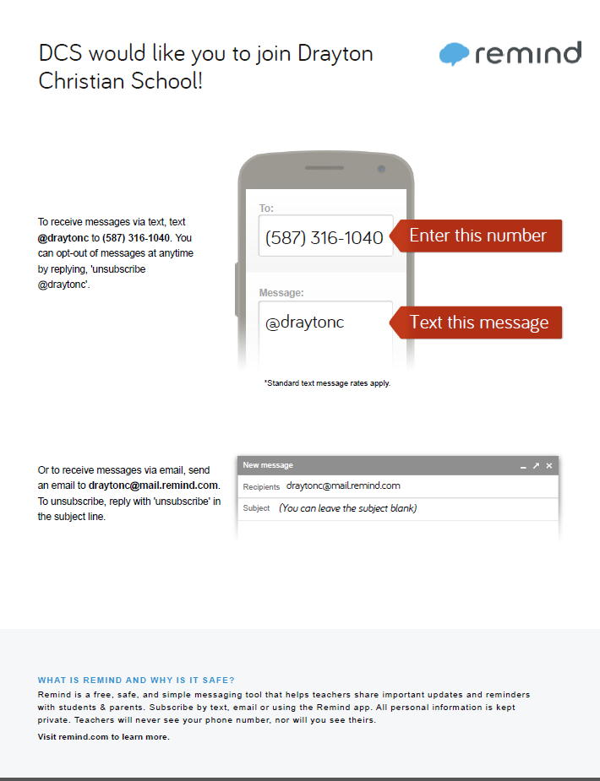

Farm to School Fundraiser

You don’t want to miss out on this fundraiser! order your Fresh, Top quality canadian Grown Vegetables and fundraiser for the school at the same time! Forms are available in the office.

Orders are due in the office by 10:00AM

Friday, october 2nd

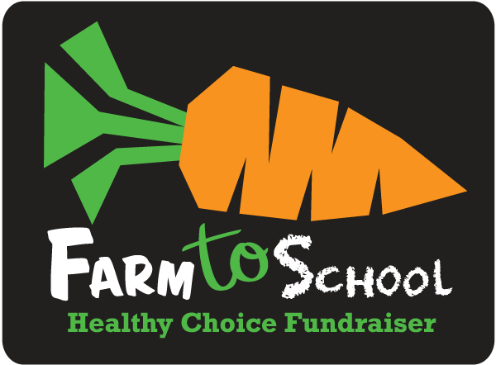

**Calling All Family Recipes!**

This year we are hoping to expand the success of school community events from years past (pancake breakfast at Christmas and Easter Potluck). Each month DCS will host an event like a family games night or a winter fun day. To help offset the cost of the events we are going to be selling DCS Cook Books with a collection of our family recipes.

We need your help! Please send us fun and favored recipes from your family. We can include pictures too! Please email Mrs. L'Henaff with your recipe!

[julianna.lhenaff@wrsd.ca](mailto:julianna.lhenaff@wrsd.ca).





Drayton Christian School Breakfast Program

We want to make sure all of our students are fully prepared for academic success. The first step is ensuring that all students begin the school day with a nutritious breakfast at home or at school.

The School Breakfast Program is available every weekday for students and food is available in the DCS Office throughout the day. Please call the office if you have any questions or would like to volunteer for this program!

A HUGE thank you goes out to all the businesses for their financial donations and to the volunteers that have made this program a great success!





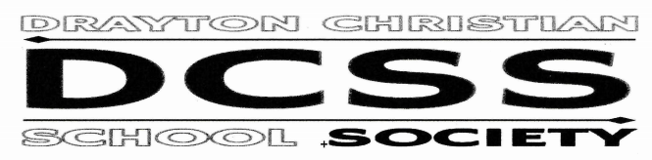

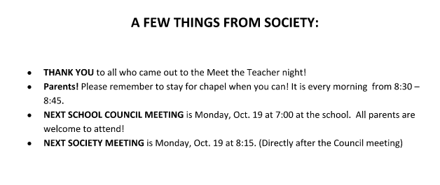

Parents, please mark October 13th on your calendar.  We will be having a combined Parent Teacher Interview and community board game night all rolled into one.  The evening will run from 5:30PM - 8:30PM.  Teachers will have interview times in their classrooms throughout the evening.

More information to come in the coming weeks.

While interviews are going on we will also have the gym set up with tables and games so that our families can come together and meet other DCS families.  Staff will also be joining us in the gym whenever they are available.

Can't wait to see you there!

Parents Who Pray

**We are a group of parents who pray for the students, staff and all other requests**

**Where: Boys & Girls Club Room**

**When: Every Thursday**

**Time: 9:00AM-9:30AM**

**Who: Everyone!! Please feel free to bring your infants and pre-school children with you as well.**



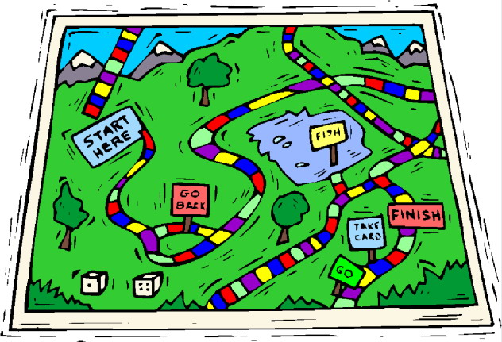

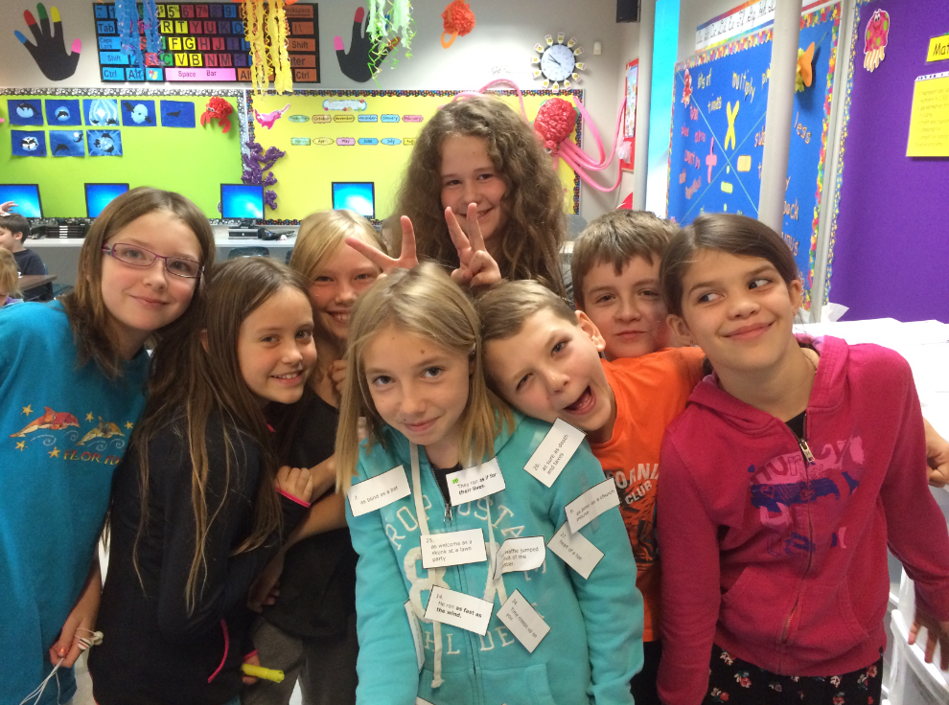

**15/16 DCS MONTHLY NEWSLETTERS:** We are continuing to move forward with technology and also trying to be environmentally friendly. If you would like to receive your newsletter by e-mail please e-mail [Elisha.Reid@wrsd.ca](mailto:Elisha.Reid@wrsd.ca)

**-- - - - - - - - - - - - - - - - - - - - - - - - - - - - - - - - - - - - - - - - - - - - - - - - - - - - - - - - - - - - - - - - - - - - - - - - - - - - - - - - - - - - - - - - - - - - - - - - - - - - - - -**



October Fire Prevention Program

October 5th at 1:00PM-3:00PM Grade 5 Kitchen Fire Safety Program

October 14th at 9:00AM-11:00AM Grade 8 Fire Extinguisher Program

October 20th at 1:00PM-3:00PM Grade 1 Smoke Detector Program



Volleyball

Girls Volleyball

Practice: mondays & Wednesdays from 3:30PM to 5:30PM

Games: October 6th DCS Vs St. A’s (At St. A’s Gym)

October 14th DCS Vs bmc 1 & 2 (At DCS Gym)

October 20th DCS VS HWP (At HWP Gym)

October 26th DCS VS Breton (At DCS Gym)

Playoffs are tuesday november 3rd at HWP

