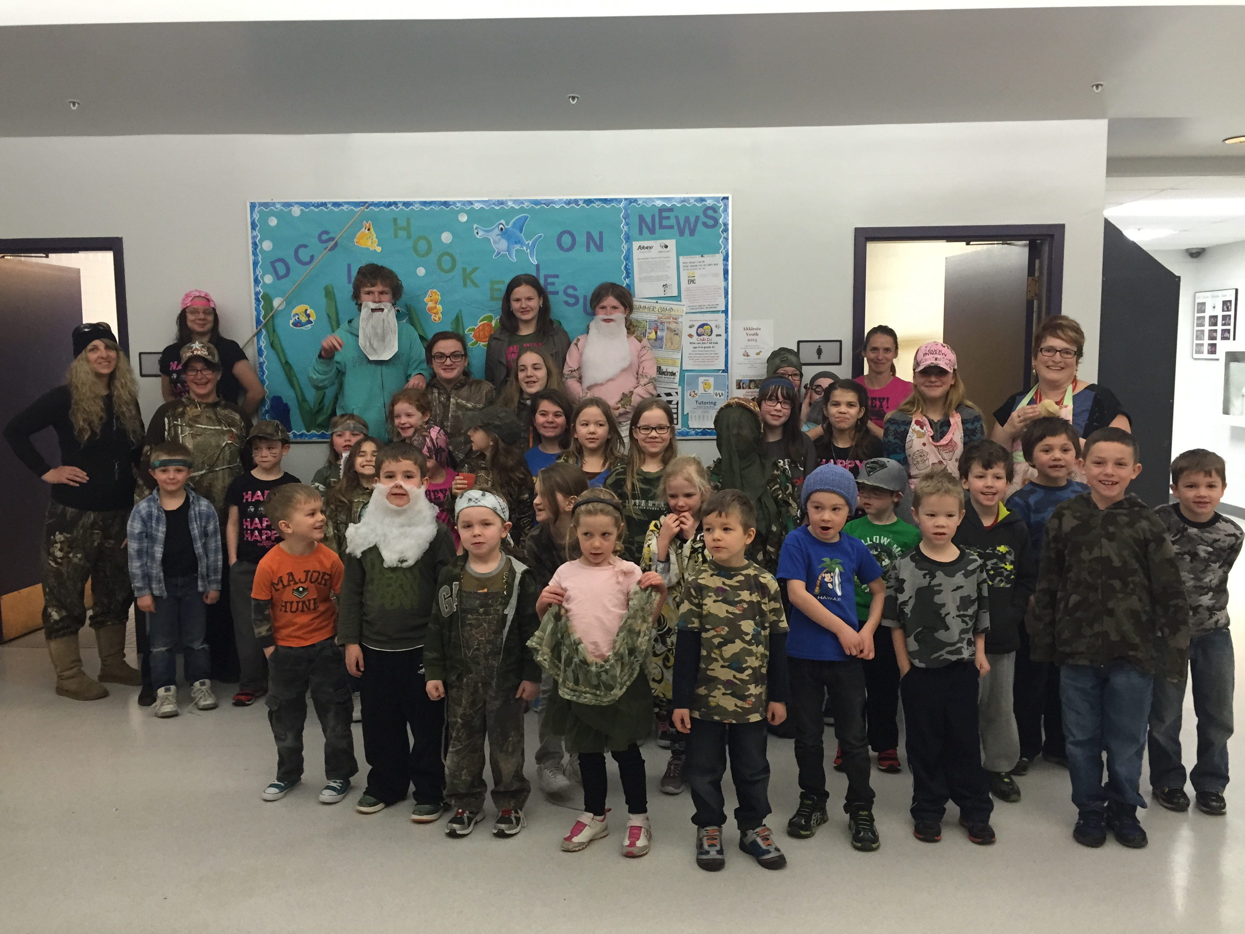

|  |  |  |  |  |  |  |
| --- | --- | --- | --- | --- | --- | --- |
|  |  | |  |  | | --- | --- | | DCS News  “Be Excellent at What is Good” |  | | April |  | |
|  |  |  |
| DUCK DYNASTY DAY!! |  | April 2015 |

Drayton Christian School has a brand new website!!

Check it out at <http://draytoncs.wrsd.ca/>





Upcoming Events at DCS!

April 7th First Day Back for students

April 13th Easter Lunch (Information will be sent home)

April 14th All School Chapel 9:00AM

April 16th Western Day

April 23rd Jr. High Chapel 9:00AM

April 28th Assemblies 9:00AM

Primary Chapel 1:00PM

**“For God so loved the world that he gave his one and only Son, that whoever believes in him shall not perish but have eternal life.” John 3:16**

**April Days Off**

April 1st & 2nd No school Spring Break

April 6th No School Easter Monday

April 17th No School for Students



We have now had the Breakfast Program running in our school for 2 months. Many students are benefiting from this program! We are offering sandwiches, cereal with milk, muffins, fruit cups, granola bars and other items in the office for students that are hungry. We have noticed a decrease in discipline issues, and feel that making sure students are well fed will increase focus during class times. If you or your business are interested in supporting this program please call Elisha Reid at the office at (780) 542-7066.

**Thank-You for your Generous Donations!**

**Church of God, Metis Cultural Youth Camp, Rhonda Mayer, ESSO, Sobey’s, Drayton Valley Bakery, Trish Kalishchuk & Mom, Drayton Valley Royal Purple**

**”For I was hungry and you gave me food, I was thirsty and you gave me drink, I was a stranger and you welcomed me.” Matthew 25:35 I was hungry and you gave me food, I was thirsty and you gave me drink, I was a stranger and you welcomed me.” Matthew 25:35**

**e food, I was thirsty and you gave me drink, I was a stranger and you welcomed me.” Matthew 25:35**

Breakfast Program

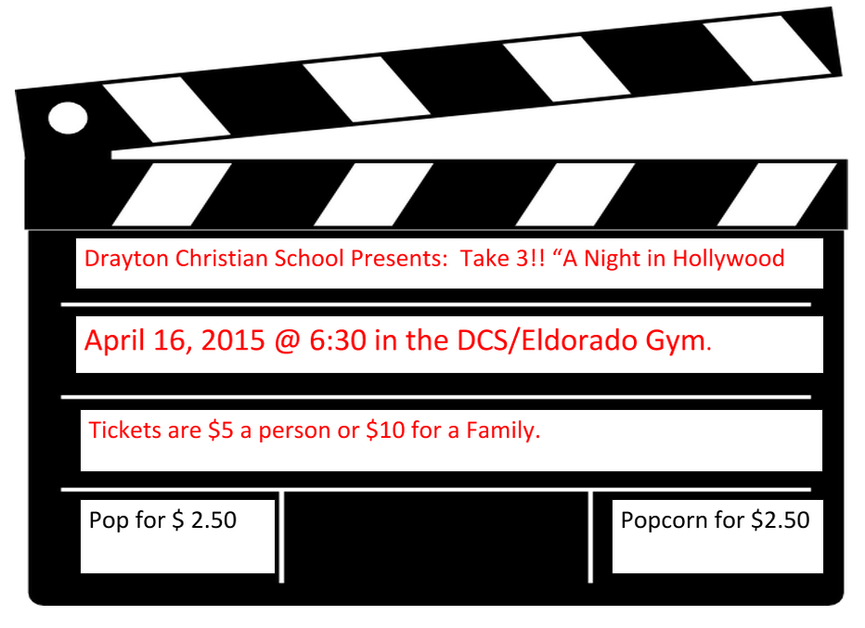

**Annual Talent Show!!**

**Any families interested in donating an item for the silent auction please call:**

**Erin Josephson at (780) 514-9587 or Tammy MacDuff at (780) 621-0137**

DCS Swim Times Mrs. Janzen’s Kindergarten Class is Swimming on: April 7, 9, 14, 16, & 21 from 2:00PM-3:00PM Forms and payment need to be sent to the school prior to swimming.





Auditions for the talent show will be taking place soon!! Start practicing your talent!!

\Junior High & Elementary School Fees and option fees are Due

Please call the office if you have any questions or concerns. Earned Fundscript amounts have been applied to outstanding amounts owing.



Kindergarten Registration

We are now accepting registration forms for the

2015-2016 kindergarten year

Please call or stop by the office

(780) 542-7066





Please e-mail [elisha.reid@wrsd.ca](mailto:elisha.reid@wrsd.ca) to receive an emailed copy of the newsletter

Parents Who Pray

**We are a group of parents who pray for the students, staff and all other requests**

**Where: DCS Art Room**

**When: Every Thursday**

**Time: 9:00AM-9:30AM**

**Who: Everyone!! Please feel free to bring your infants and pre-school children with you as well.**



**2015/16 Continuing Enrollment**

Each DCS student received a registration confirmation letter with their report card.

***In order to assist us in planning for the 2015/16 school year, please fill out the form and send it back to the office as soon as possible.***

If you know of any families who are interested in enrolling their children at DCS, please send them to the school and we will be happy to show them around and give them a registration package. Please keep our staff in prayer as they begin to set up for the 2015/16 school year!

**Music Festival**

**We would like to wish all students performing in the local music festival good luck!**





All kids love water and our playground is wet! Please send extra clothing in your child’s backpack in case he/she splashes too much in the puddles



Western Day!

Come dressed in your Western Outfits!! Yee Haw!

Thursday, April 16th 2015

Please e-mail [Elisha.reid@wrsd.ca](mailto:Elisha.reid@wrsd.ca) to receive an e-mailed copy of the newsletter



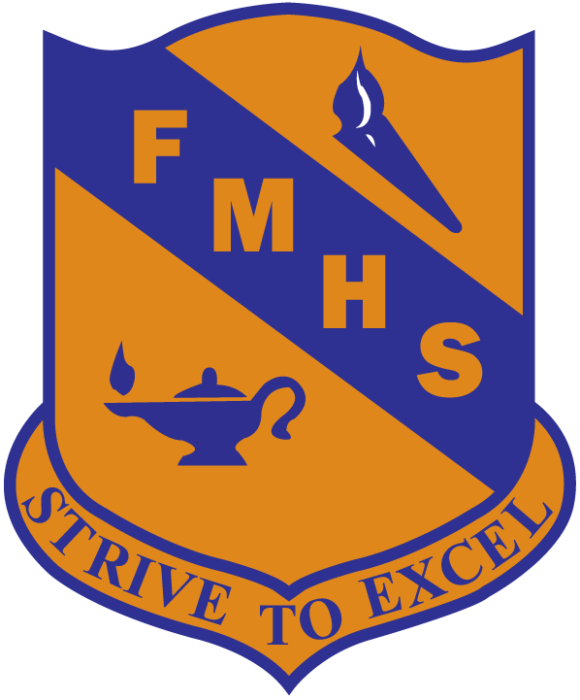

Frank Maddock High School Parent Orientation Night:

Wednesday, April 15th in the Max at 7:00PM.