

|  |  |  |  |  |
| --- | --- | --- | --- | --- |
|  |  | |  | | --- | | DCS News  “Be Excellent at What is Good” | | February | |
|  |  |  |
| Junior High Foods Option |  |  |



# Exciting Times at DCS!

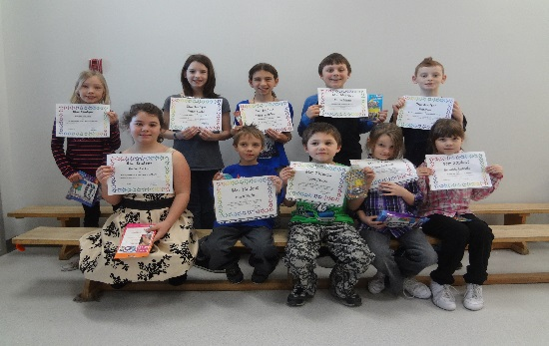

Star Students for January

Each month our Grade 1 -6 teachers recognize different students . Congratulations to all our January students!

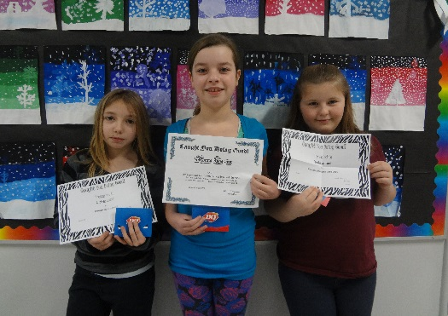

Caught You Doing Good

### Jr.High Basketball

by Name Style

**Basketball Game Schedule**

**Feb 3rd**

**4:00PM Girls @ DCS 5:30PM Boys @ DCS**

**Feb 10th**

**4:00PM Girls @ DCS 5:30PM Boys @ DCS**

**Feb 11th**

**4:00PM Boys @ Breton**

**Feb-12th**

**4:00PM Girls @ Buck Mountain**

**February 19th**

**4:00PM Girls @ St. Anthony’s 5:30PM Boys St Anthony’s**

**February 26th**

**4:00PM Girls @ DCS 5:30PM Boys @ DCS**

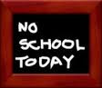

**February 5th & 6th No School**

**February 16th- Family Day No School**



**February 25th, 2015**

**Hot Lunch Menu**

**Monday:**

Cheese & Pepperoni Pizza $2.50

**Tuesday:**

Chilli Cheese Dog $3.00

Hot Dog $2.50

Bowl of Chilli $2.50

**Wednesday:**

Taco Salad $3.00

**Thursday:**

Chicken Ranch Wraps $2.50

**Friday:**

Grilled Cheese $2.50

Tomato Soup $1.00

Chocolate Milk, White Milk & Slushes available everyday $1.00

Hot Lunch Tickets will be available in the Office or Cash will be accepted



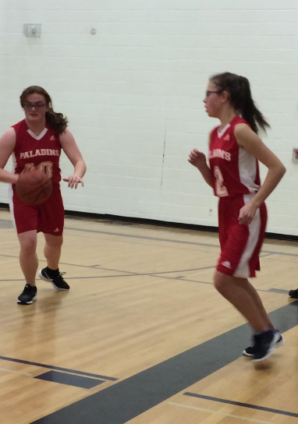

**Chapel & Assembly Dates**

**February 3rd Primary Chapel @ 1:00PM**

**February 10th All School Chapel @ 9:00AM**

**February 19th Grade 4-6 Chapel @ 9:00AM**

**February 24th Junior High Chapel @ 9:00AM**

**February 27th Assembly @ 9:00AM**



Kindergarten Registration

We are now accepting registration forms for the

2015-2016 kindergarten year

Please call or stop by the office

(780) 542-7066

Parents Who Pray

**We are a group of parents who pray for the students, staff and all other requests**

**Where: DCS Art Room**

**When: Every Thursday**

**Time: 9:00AM-9:30AM**

**Who: Everyone!! Please feel free to bring your infants and pre-school children with you as well.**





**FUNDSCRIP: Want to pay off your swimming lessons, option fees, or WRPS fees without spending money? Use Fundscrip! This system works by pre-buying gift cards for the things you already buy or for gifts. Cards can be purchased for groceries, fuel, and clothing, as well as many other options. Fundscrip then gives you the cards for the full amount and the school a percentage of each card (every card is different) which we hold in an account for you to use towards your child’s fees. We are now allowing you to pay your mandatory school fees but these fees must be paid by May 1st, 2015. You can also use them for all other fees such as swimming, skating, field trips, options etc. Some families have not paid a penny of their own money to pay for these things in the last couple of years.**

**

School Accountability Survey

**As an annual check-up on the education system, the Accountability Pillar provides an opportunity for Alberta Education and school authorities to ensure that we are equipping students for success.**

**The Accountability Pillar uses a set of 16 indicators consisting of surveys of students, parents, and teachers on various aspects of quality.**

**All surveys are anonymous and ask questions about experiences with the school. Your participation in the survey helps to provide important information on the quality of education your child is receiving, so we encourage you to return your survey promptly.**

**Survey results will be available to school authorities in May 2015, and will be reported publicly as part of their 3-Year Education Plans and Annual Education Results Reports.**



Please e-mail [Elisha.reid@wrsd.ca](mailto:Elisha.reid@wrsd.ca) to receive your newsletter by e-mail.

*DCSS Fundraiser*

Help the DCSS to raise money for the Drayton Christian School. Shop online at [robyn.mialisia.com](http://robyn.mialisia.com/) to support your kids!  
20% of all sales will go back to DCSS and for each Event booked from this fundraiser, another $20 in FREE Jewelry will be offered to DCSS.  
Please invite other DCS family & friends to attend this event to place their orders to support our school. This event will end at midnight on Feb 6.