|  |  |  |  |  |
| --- | --- | --- | --- | --- |
| https://scontent-a.xx.fbcdn.net/hphotos-xpf1/v/t1.0-9/10408581_332208643639415_7456423870722835365_n.jpg?oh=aeb0829b7bc8922648ab49a275879940&oe=552BDA6E |  | |  | | --- | | DCS News  “Be Excellent at What is Good” | | January | |
|  |  |  |
| ECS Birthday Party for Jesus |  |  |



**DCSS Parent Council Meeting**

**January 19th, 6:00PM-10:00PM**

**We will be reviewing our society constitution and creating bylaws for our new school council.**

**All are Welcome!!**

Happy New Year!!

**January 16th, 2015**

**Dress up Day**

**Dress up like your favorite comic book or story book character.**



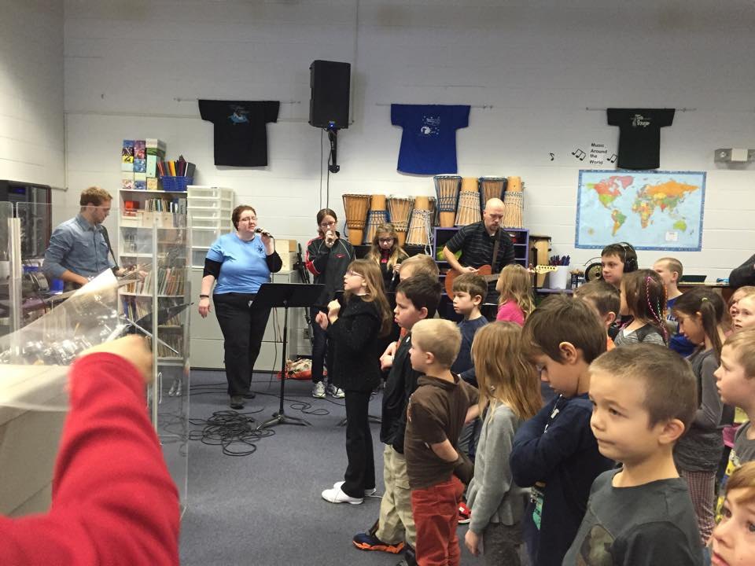

Chapel Dates:

**January 12, 2015**

**All School Chapel 9:00AM**

**January 20, 2015**

**Grades 4-6 Chapel 9:00AM**

**January 23, 2015**

**Junior High Chapel 9:00AM**

**Kindergarten- Grade 3 Chapel 1:00PM**



December Skating

[Sidebars are great for calling out important points from your text or adding additional info for quick reference, such as a schedule.

They are typically placed on the left, right, top or bottom of the page. But you can easily drag them to any position you prefer.

When you’re ready to add your content, just click here and start typing.]



**Inclement Weather Days**



**No School January 30th , 2015**

On Snow Days, (where busses aren’t running) the Hot Lunch Mom’s **will not** be coming in to prepare Lunch. If your children are coming to school, please send them a bag lunch.

To find out if busses aren’t running, please check **wrsd.ca** website for up to date information. The link is located on the bottom of their home page.

Check it out for current information!

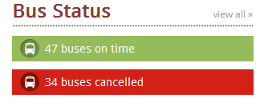

Volunteers Needed

**We are in need of some parents to help out with our amazing hot lunch program. We are looking for help every other week. Please call the office if you would like to help give our kids a delicious hot meal!**

A free App is also available to download on Smart phones!

Search **Wild Rose Public Schools**

**Hot Lunch Menu**

**Monday:**

Cheese & Pepperoni Pizza $2.50

**Tuesday:**

Chilli Cheese Dog $3.00

Hot Dog $2.50

Bowl of Chilli $2.50

**Wednesday:**

Taco Salad $3.00

**Thursday:**

Chicken Ranch Wraps $2.50

**Friday:**

Grilled Cheese $2.50

Tomato Soup $1.00

Chocolate Milk, White Milk & Slushes available everyday $1.00

Hot Lunch Tickets will be available in the Office or Cash will be accepted



Parents Who Pray

**We are a group of parents who pray for the students, staff and all other requests**

**Where: DCS Art Room**

**When: Every Thursday**

**Time: 9:00AM-9:30AM**

**Who: Everyone!! Please feel free to bring your infants and pre-school children with you as well.**



**Grade 5-9**

**Parents, we will be having an important informationnight.**

**Please watch for details!**

A few great pictures from the 2014

DCS Christmas Concert!!

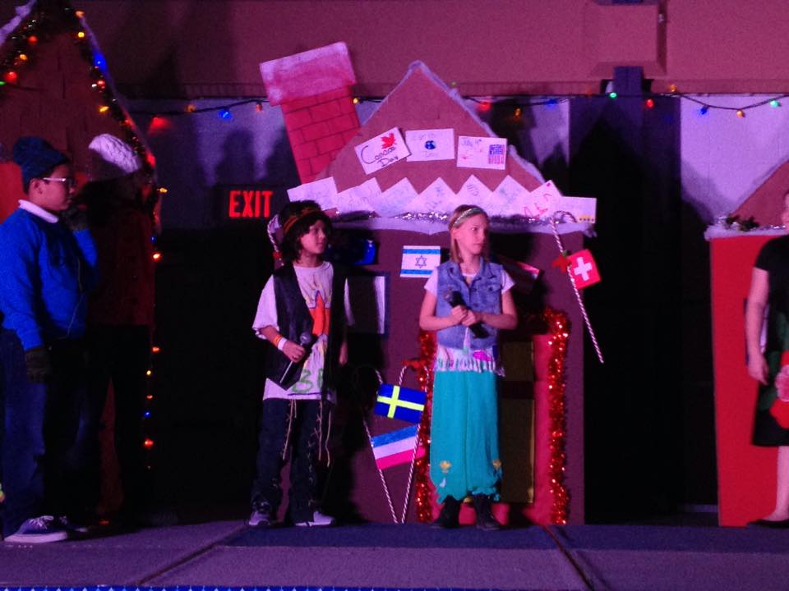



Season Starts January 12th, 2015

Practice information and game schedules will be sent out soon!!



Basketball

**

**FUNDSCRIP: Want to pay off your swimming lessons, option fees, or WRPS fees without spending money? Use Fundscrip! This system works by pre-buying gift cards for the things you already buy or for gifts. Cards can be purchased for groceries, fuel, and clothing, as well as many other options. Fundscrip then gives you the cards for the full amount and the school a percentage of each card (every card is different) which we hold in an account for you to use towards your child’s fees. We are now allowing you to pay your mandatory school fees but these fees must be paid by May 1st, 2015. You can also use them for all other fees such as swimming, skating, field trips, options etc. Some families have not paid a penny of their own money to pay for these things in the last couple of years.**

**Due Dates: January 9th, January 23rd, & February 9th**