Principal’s Message

As advent has begun, we have a time to reflect and celebrate the birth of our Lord Jesus Christ! Throughout the school, students are signing Christmas Carols in preparation for our Christmas Concert on December 18th. Classes are focusing on hope, joy, love & peace in hopes that we can be a light to our community. One way we have already spread the love of Christ was with our Operation Christmas Child shoe boxes which totaled 80 boxes. Thank you for your support.

We now turn our focus to the community of Drayton Valley with our Santa’s Anonymous campaign. Please help us provide basic necessities, toys, and food for local families. Our goal is to fill up a tent that will soon be in our foyer. May your Christmas be filled with the joy and peace that only Christ can bring!





**Enjoy your long weekend for the following day:**

**Friday, December 5th**

**Primary Chapel December 4th at 1:05 - 2:05PM**

**4-6 Chapel December 10th at 9:00AM**

**Junior High Chapel December 18th at 9:00 AM**

**Please join us in the music room to celebrate Jesus’ love for us.**

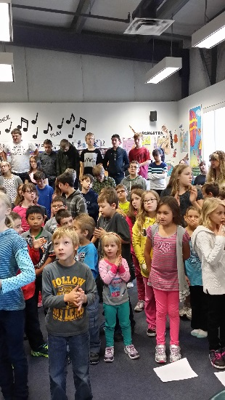

|  |  |  |  |  |
| --- | --- | --- | --- | --- |
|  |  | |  | | --- | | DCS News  “Be Excellent at What is Good” | | December | |
|  |  |  |
|  |  |  |



***Junior High Lasertag with AXIS! It was lots of fun!!***

With the chilly weather upon us please make sure to send your child to school with warm clothing.



*Christmas Break Will be from December 20th 2014 to January 4th, 2015. Enjoy your time off with family and friends celebrating the birth of our Lord Jesus!*



Christmas Concert

December 18th at 7pm

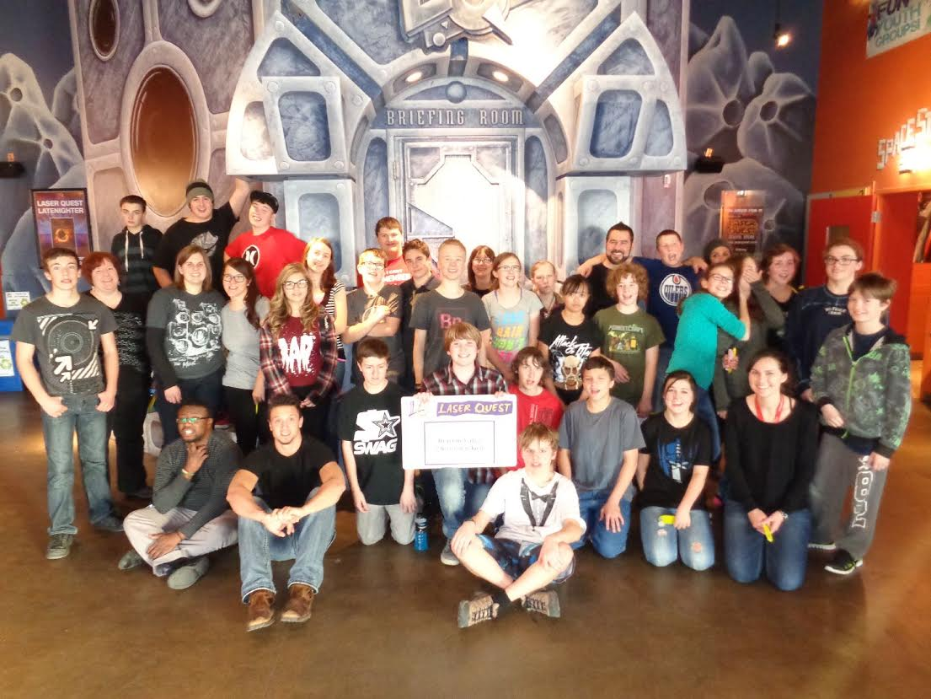

**Parent Teacher Interviews**

If you would like to meet with your child’s teacher please call the office.

780-542-7066

Interviews are Dec 3rd starting at 5:30pm.



**Sports Jersey Day!**

**December 4th**



Hot Lunch Menu

**Monday:**

Spaghetti & Meat Sauce with Garlic Bread- $3,

Chicken Noodle Soup- $1

**Tuesday:**

Baked Mac n’ Cheese with Ham- $3,

Veggie’s & Dip- $1

**Wednesday:** Chicken Caesar Salad with a Cheese Bread Stick-$3,

Vegetable Soup- $ 1

**Thursday:** Chicken Ranch Wraps -$2.50

**Friday:** Your Choice of Pepperoni or Cheese Pizza -$2.50

We are still in need of some wonderful parents to come in and help cook delicious lunches! Please note that if the busses are not running there is **NO** hot lunch that day. To help out, please call the office at (780)542-7066



Drayton Christian School Society Meeting

December 15th 2014

6:30-8:30

Everyone Welcome!

**Family Pancake Breakfast & Pajama Day!! December 19th at**

**9:00 AM.**

**Please join us for a delicious Breakfast**

**FUNDSCRIP: Want to pay off your swimming lessons, option fees or WRPS fees without spending money? Use Fundscrip! This system works by pre buying gift cards for the things you already buy or for gifts. Cards can be purchased for groceries, fuel and clothing as well as many other options. Fundscrip then gives you the cards for the full amount and the school a percentage of each card (every card is different) which we hold in an account for you to use towards your child’s fees. We are now allowing you to pay your mandatory school fees but these fees must be paid by May 1st, 2015. You can also use them for all other fees, such as, swimming, skating, field trips, options etc. Some families have not paid a penny of their own money to pay for these things in the last couple of years.**

** 

***Boys & Girls Club Out of School Care***

***In addition to our regular programming (after school to 6:00pm on school days), we are offering four full day camps (8:00am to 5:00pm) during the month of December and over the Christmas Break.***

***Friday, December 5***

***Monday, December 22***

***Tuesday, December 23***

***Friday, January 2***

***The details of each day camp are yet to be finalized, but we hope to include Christmas activities, skating, and much more!  Contact Sandie at*** [***780-514-3400***](tel:780-514-3400) ***for more information or to register.  Camps are $35 per day.  We hope to see you there.  Merry Christmas everybody!***

St.Anthony School will be holding their Living Nativity on Wednesday December 17th ,2014 @ 2pm and 7pm. 

**Tomahawk Immanuel Lutheran Church** will be holding their Live Nativity on Saturday December 20th @ 7pm.



A touching and whimsical re-enactment of the events surrounding the birth of our Savior, this outdoor performance with live animals will touch your hearts. Please dress warm and join us for warm drinks and snacks following the 20 minute outdoor performance. *Please note in weather that is not suitable for man nor beast the performance may be moved indoors and subsequently may not have live animals.*

Please send an e-mail to [Elisha.Reid@wrsd.ca](mailto:Elisha.Reid@wrsd.ca) if you would like to receive an e-mailed copy of the newsletter

December 2014 Skating Times

**Kindergarten to Grade 3**

**December 8th, 10th, 16th, & 17th 1:30-2:30**

**Grades 4-6**

**December 8th, 10th, 15th, & 17th 11:00-12:00**

**Junior High**

**December 8th, 10th, 12th, 16th & 18th 2:00-3:00**

**We are starting up a Random Act of Kindness Project, where students will be asked to pay close attention to the variety of ways that kindness is shown in school, at home and in the community. This does not only mean the kindness that they may show to others, but also kindness that is shown to them or even kindness that they may see in others.  When students offer kindness to someone or something, or see kindness been shown, they will record the act on a random act of kindness card which will be provided. These cards will then be collected either in the students classrooms or in a random act of kindness box which will be located in the office.   These kind acts will then be shared on a colored piece of paper with a helping hand printed on it and pasted on the wall above student lockers.  Our goal is to have these acts of kindness surround all of the hallways at DCS, by the end of the school year.**

Random Acts of Kindness

## 