DCS News: Safety Edition 2018/2019
Absent From School

If your child is absent please notify the school by
leaving a message on our school answering machine before 8:40
(780) 542-7066.
Please do not send foods containing nuts to school.
We want to keep the members of our school family with severe allergies safe.
Communication

We use the Remind App
Please sign up below by texting:
DCS Office (All School Events): Text @draytonc to 587-316-1040
Pre-K text @ddfhd6 to 506-802-9464
Kindergarten: Text @37dkee to 506-802-9464
Grade 1: Text @8g9kae to 587-316-1040
Grade 2/3: Text @84g4bd to 437-800-0547
Grade 4/5: Text @dg4e8b to 587-316-1040
Grade 5/6: Text @hebg86 to 587-316-1040
Grade 7 Miss K: Text @2ahh79 to 902-800-6578
Grade 7 Mr. Wang: Text @3hc94k2 to 289-278-3153
Grade 8/9 Mr. Wang: Text @h6dfe7 to 289-278-3153
Grade 8 Miss K: Text @e6dkef to 902-800-6578
Grade 9 Miss K: Text @43g6g2a to 902-800-6578
Junior High Volleyball: Text @gega24 to 506-802-9464
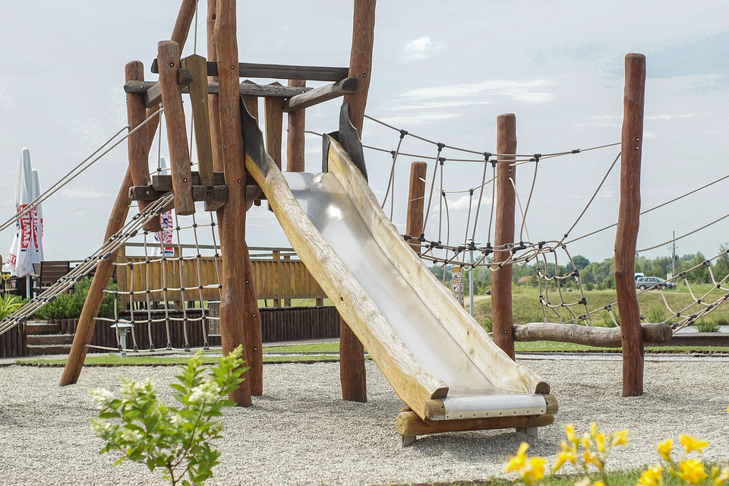 | Morning Routine  School starts at 8:31  Pre-K, Kindergarten, & Grade 1 may enter at front doors between 8:20 and 8:31.  Grade 2-9 play outside until 8:31 and then line up at their doors.  Outside Supervision begins at 8:20 AM
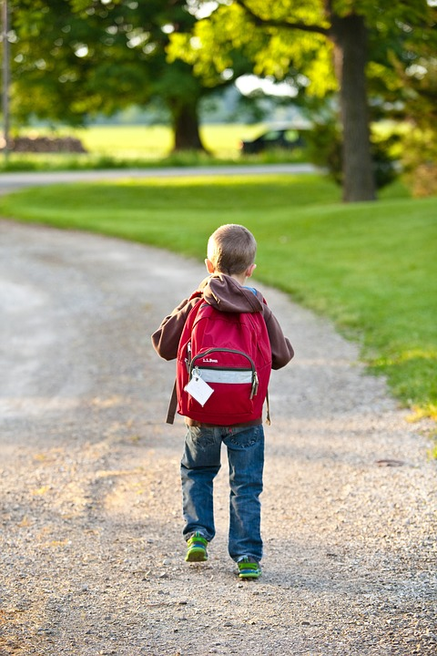 | Pick Up / Drop Off  Every student’s safety is important to us. It is crucial that we know who is in our building at all times. We require:  - All guests including parents to sign in at the office and wear a visitor tag.  - Parents are welcome to wait in our front foyer until the dismissal bell rings. Your child will be leaving out of their regular entrance door. Please meet your child at a designated meeting place outside to reduce congestion in our growing school.
Inside Please | Inside Recess  During inclement weather a Green Dot will be posted on our doors to indicate that recess will be inside when it is:  - Raining Heavily  - -20 Celsius including wind chill  Please dress your child for the weather as they will go outside if at all possible.
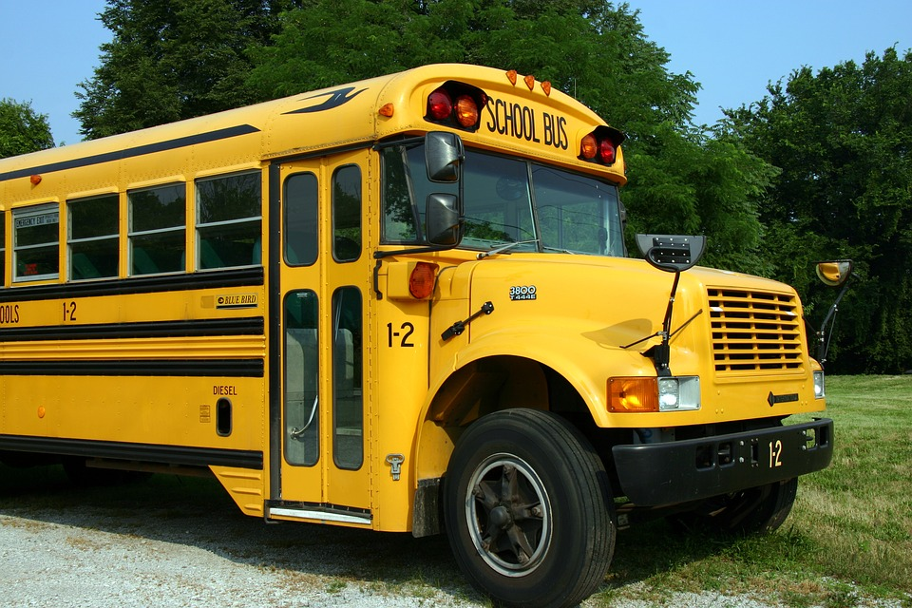 | Bus Cancellations  Schools in the Wild Rose School Division will stay open all day on regularly scheduled school days regardless of the weather, providing that the building is deemed safe and comfortably heated.  When buses do not run, and parents choose to deliver the child to school, the parent shall also be responsible for ensuring safe transportation home for the student, unless notified otherwise.  Please use good judgment and care when deciding whether or not to send your child(ren) when weather conditions are extreme or when there is danger of roads being blocked.
Fire Drills & Lockdown Practise

We practise emergency protocol regularly so that we are well prepared. Regular practise also helps children to remain calm and confident that they are safe.

