Our faith based Pre-Kindergarten program is a language rich program that adheres to the philosophy of learning through play. Pre-Kindergarten is a quality, early learning, play based program focused on readiness, literacy and numeracy skills. Our hope is that your child begins to unpack all the gifts that make them completely unique as they become fully alive in God’s story at Drayton Christian School.

Our program includes:
• Certified teacher
• Half-day programming, 3 mornings/week, September to June
Program Requirements:
• Screening required for speech, language and readiness needs
Program Fees:
• One-time fee of $30 for students who have a moderate to severe speech delay or who qualify for PUF funding (there will be no other fees)
• $175/month (fee may be waived if there is a developmental delay)
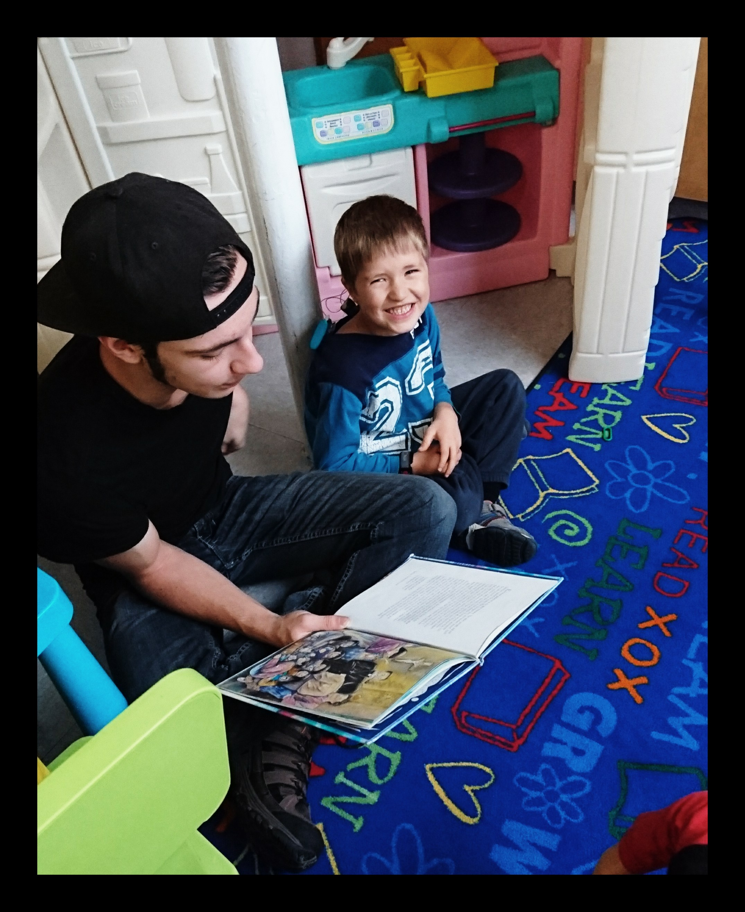
Contact our school at 780.542.7066
to arrange an admission meeting.
